National Park Travel Guide

# Capitol Reef National Park

## Description

Located in south-central Utah in the heart of red rock country, Capitol Reef National Park is a hidden treasure filled with cliffs, canyons, domes, and bridges in the Waterpocket Fold, a geologic monocline (a wrinkle on the earth) extending almost 100 miles.

## Weather

Weather is posted daily; check at the park visitor center for weather updates. Do not enter into narrow canyons if there is a threat of rain or if rain has been falling in the area. Rain and snow may also make dirt roads impassable to vehicles.

## Activities

* Arts and Crafts
* Biking
* Canyoneering
* First Person Interpretation
* Hands-On
* Horse Camping (see also Horse/Stock Use)
* Horse Trekking
* Living History
* Park Film

## Images

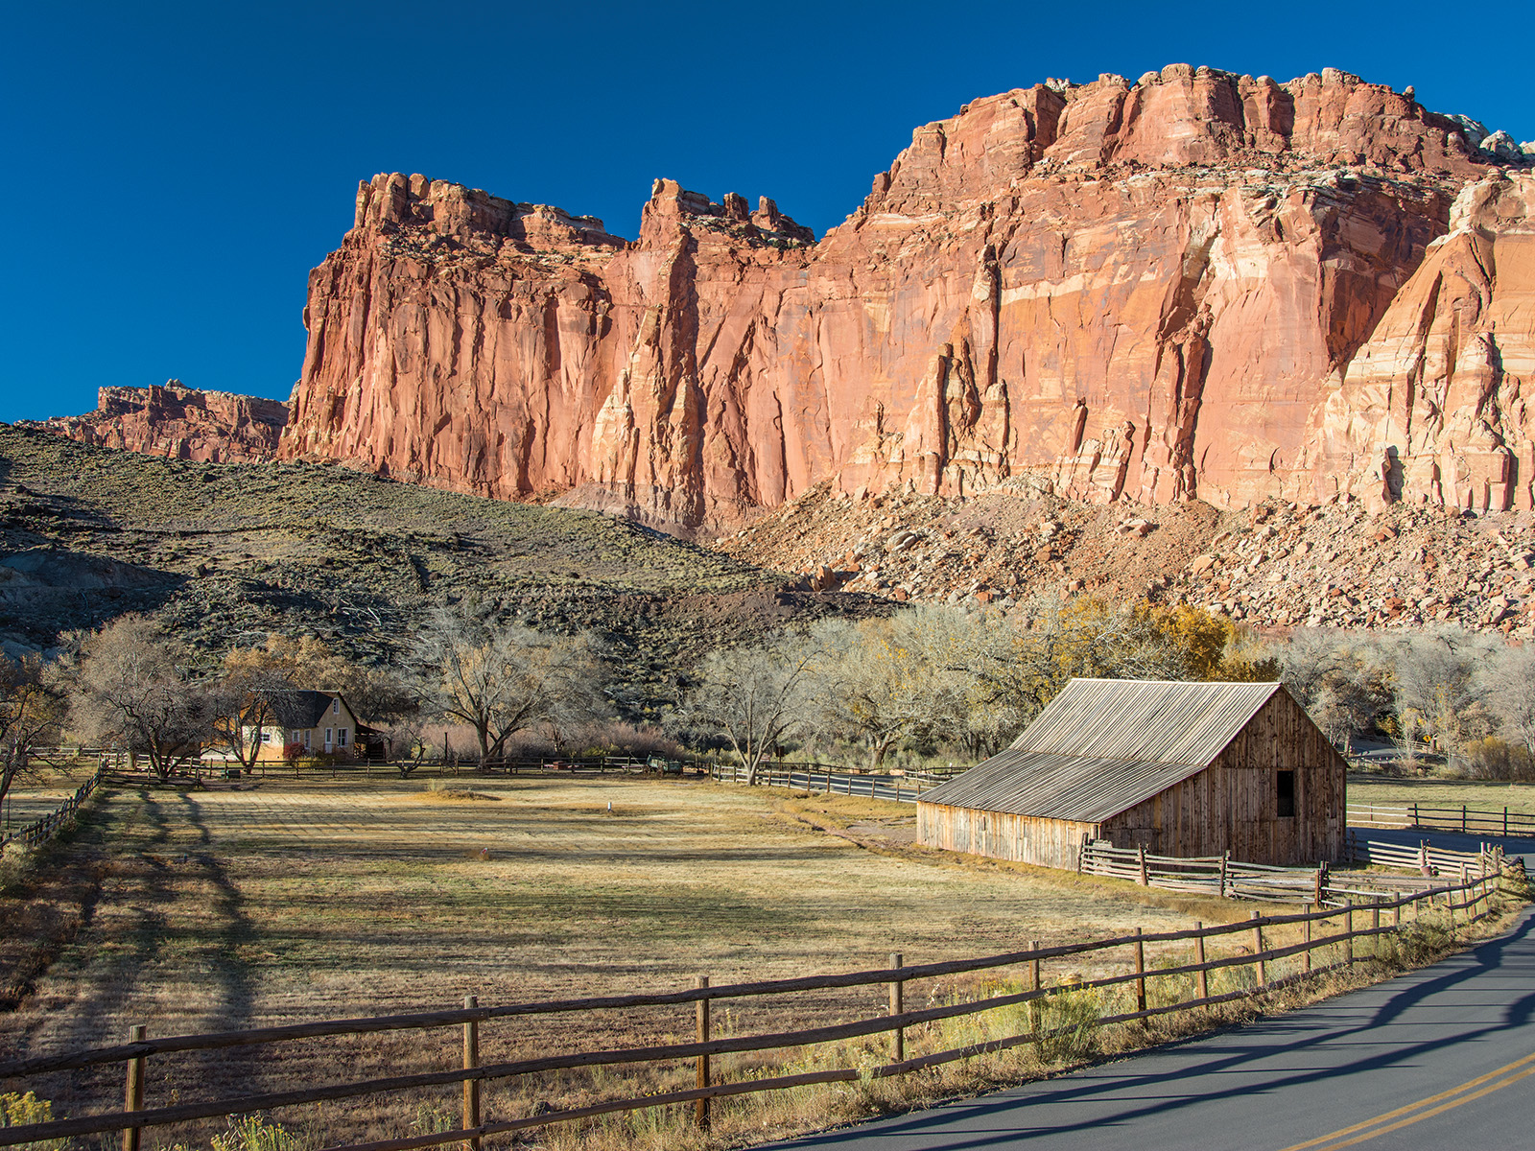

Gifford House and Pendleton Barn. NPS Photo

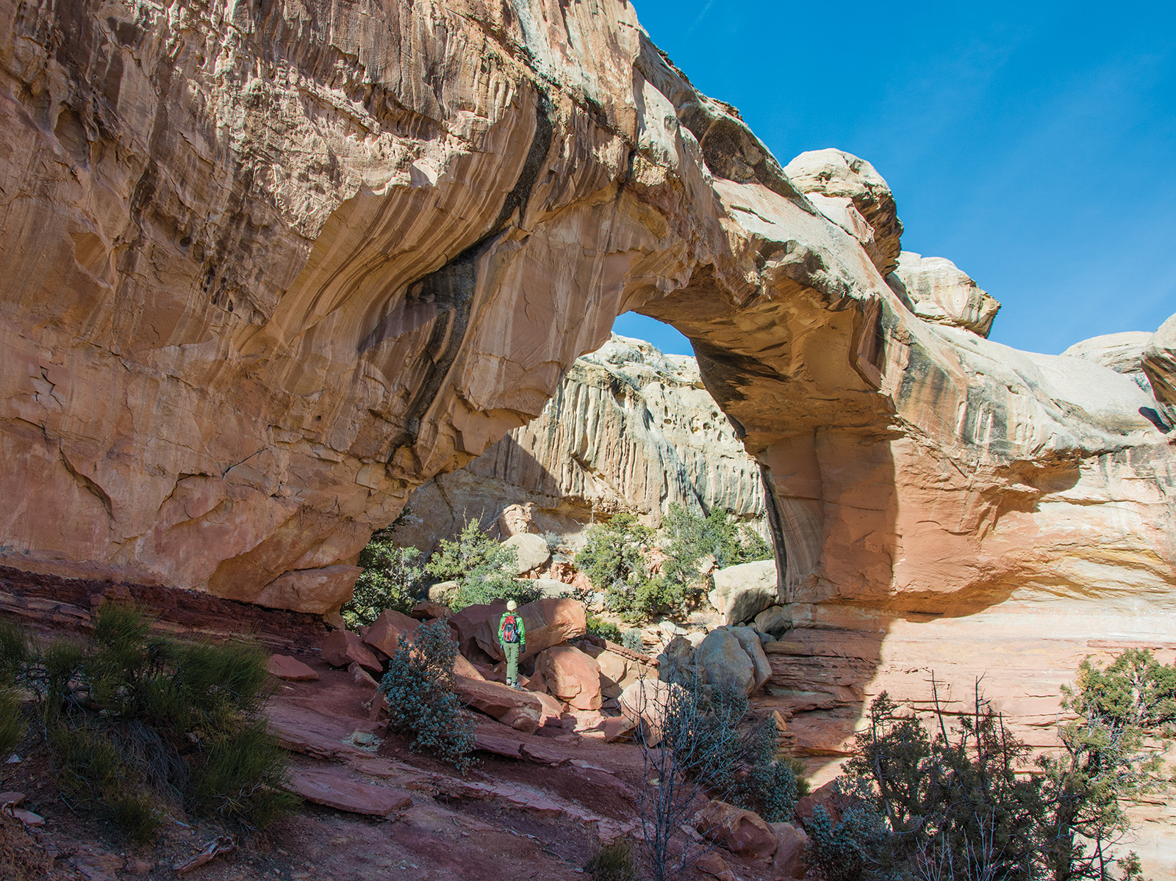

Hickman Bridge. NPS Photo

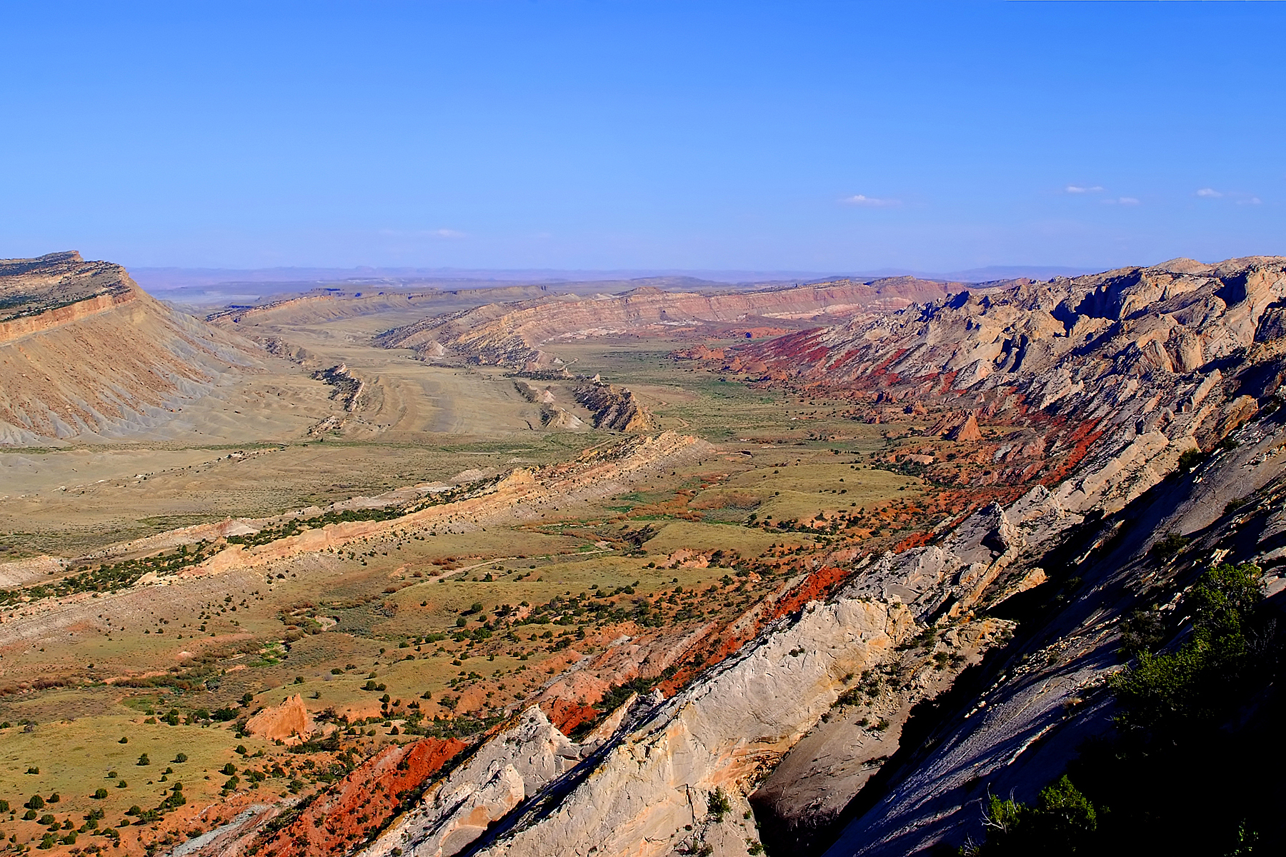

Strike Valley. NPS Photo

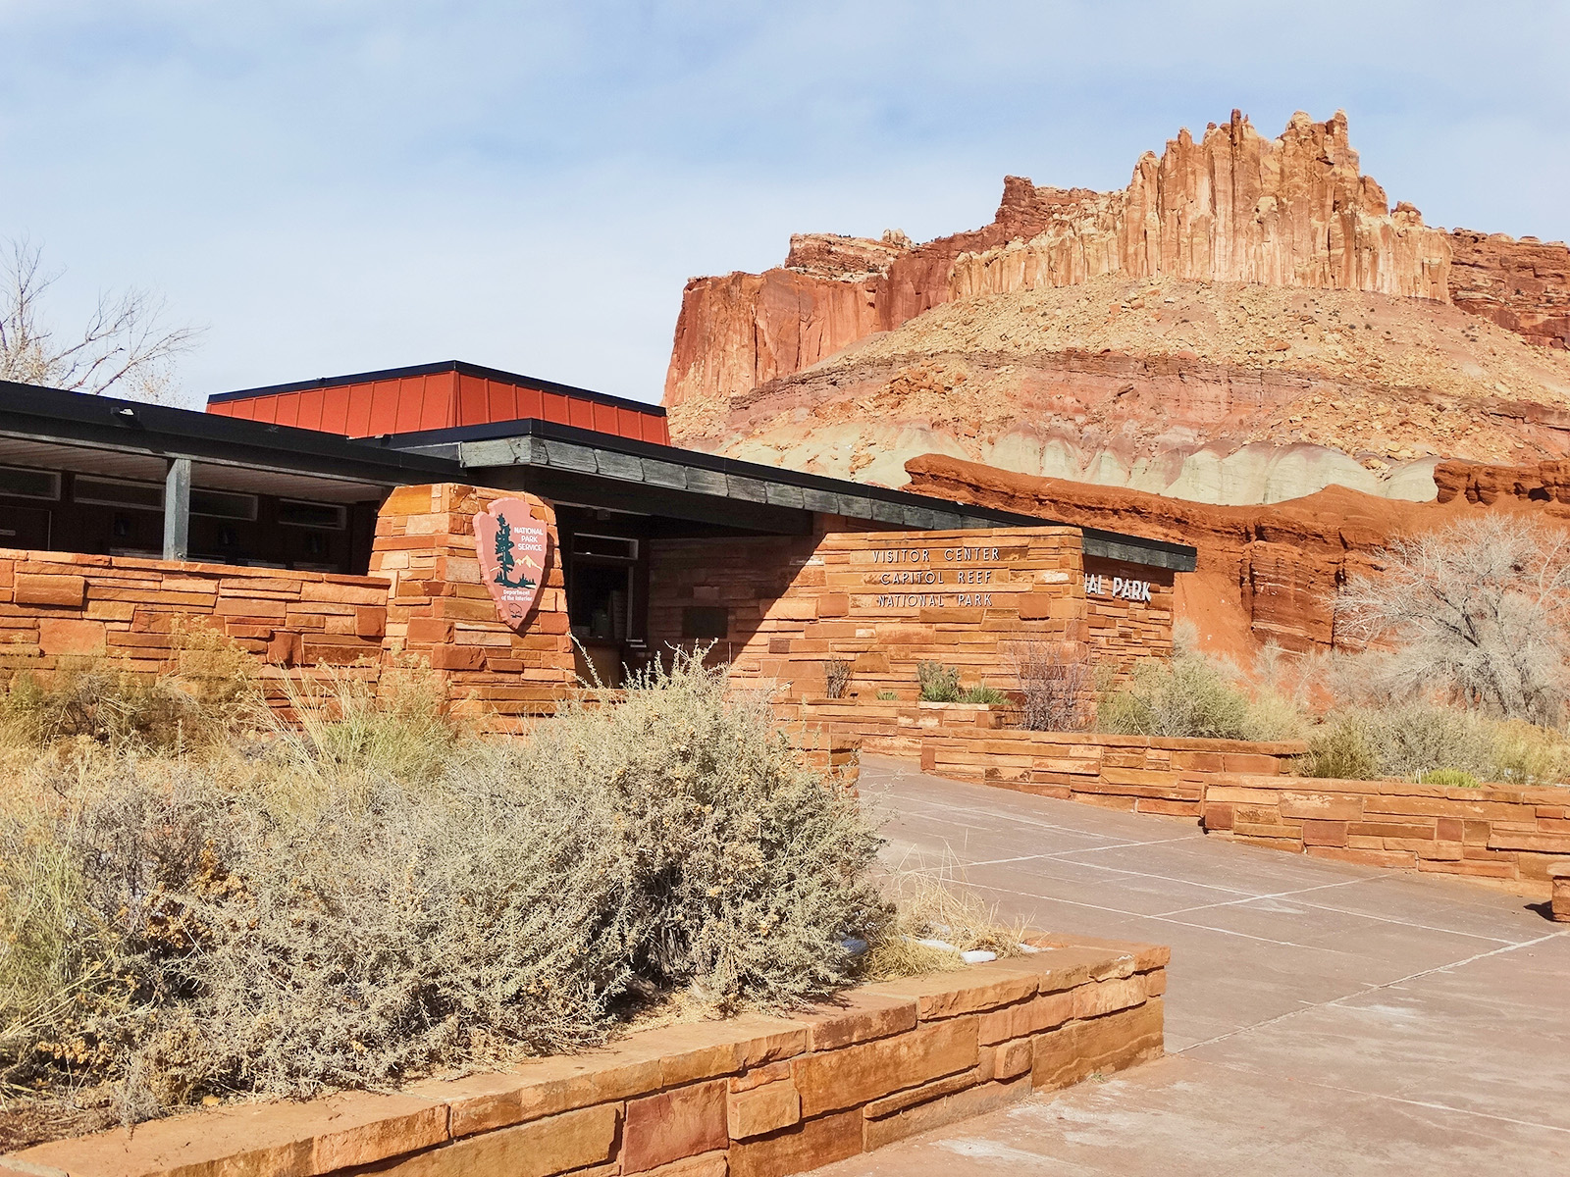

Capitol Reef Visitor Center with "The Castle". NPS Photo

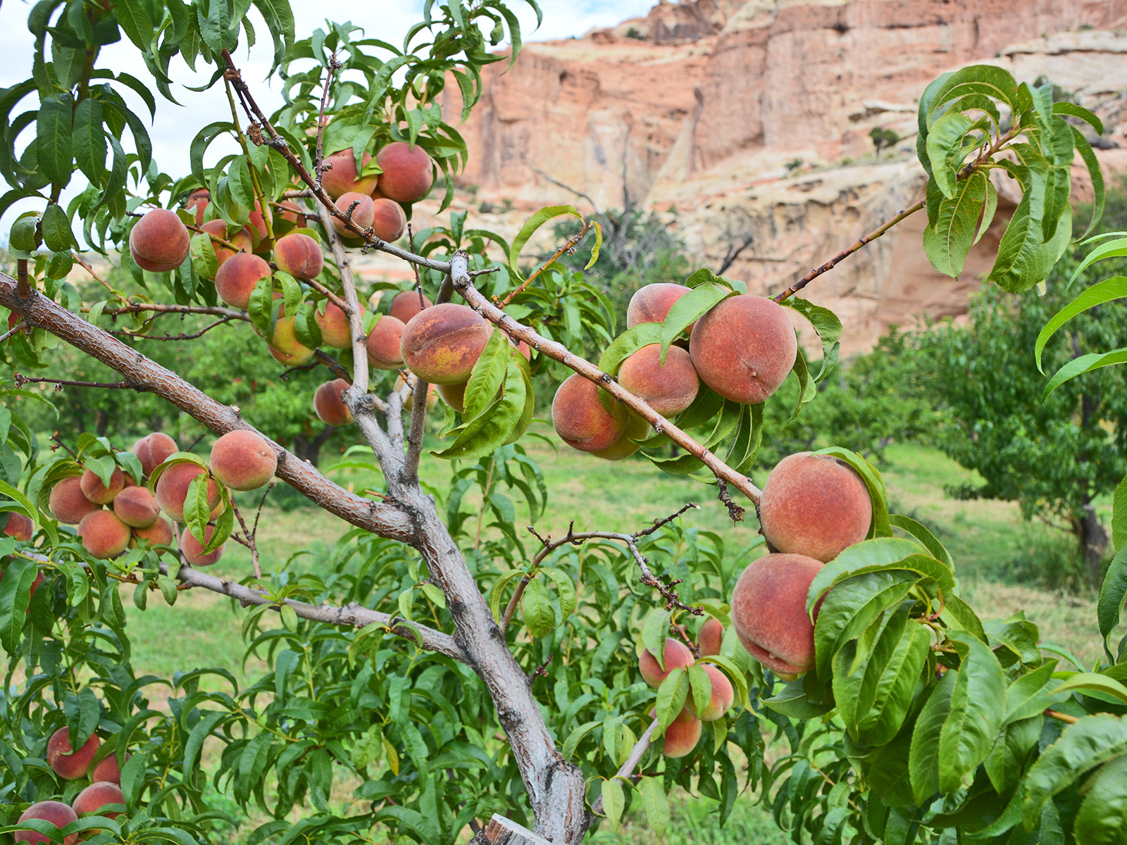

Capitol Reef Peach Orchard. NPS Photo

## Operating Hours

Capitol Reef is a 24 hour park, open all day, every day. The visitor center is open daily, except for some major holidays. Visitor center hours vary, call 435-425-3791 and follow the prompts for current visitor center information.

## Contact Information

### Address

52 West Headquarters Drive  
UT  
84775

### Website

https://www.nps.gov/care/index.htm

# Kenai Fjords National Park

## Description

At the edge of the Kenai Peninsula lies a land where the ice age lingers. Nearly 40 glaciers flow from the Harding Icefield, Kenai Fjords' crowning feature. Wildlife thrives in icy waters and lush forests around this vast expanse of ice. Sugpiaq people relied on these resources to nurture a life entwined with the sea. Today, shrinking glaciers bear witness to the effects of our changing climate.

## Weather

The weather Kenai Fjords is difficult to predict and can change rapidly. The area generally enjoys a relatively temperate maritime climate, primarily due to the influence of the Japanese current that flows through the Gulf of Alaska. Summer daytime temperatures range from the mid 40s to the low 70s (Fahrenheit). Overcast and cool rainy days are frequent. Winter temperatures can range from the low 30s to -20.

## Activities

* Astronomy
* Boating
* Fixed Wing Flying
* Front-Country Hiking
* Junior Ranger Program
* Mountain Climbing

## Images

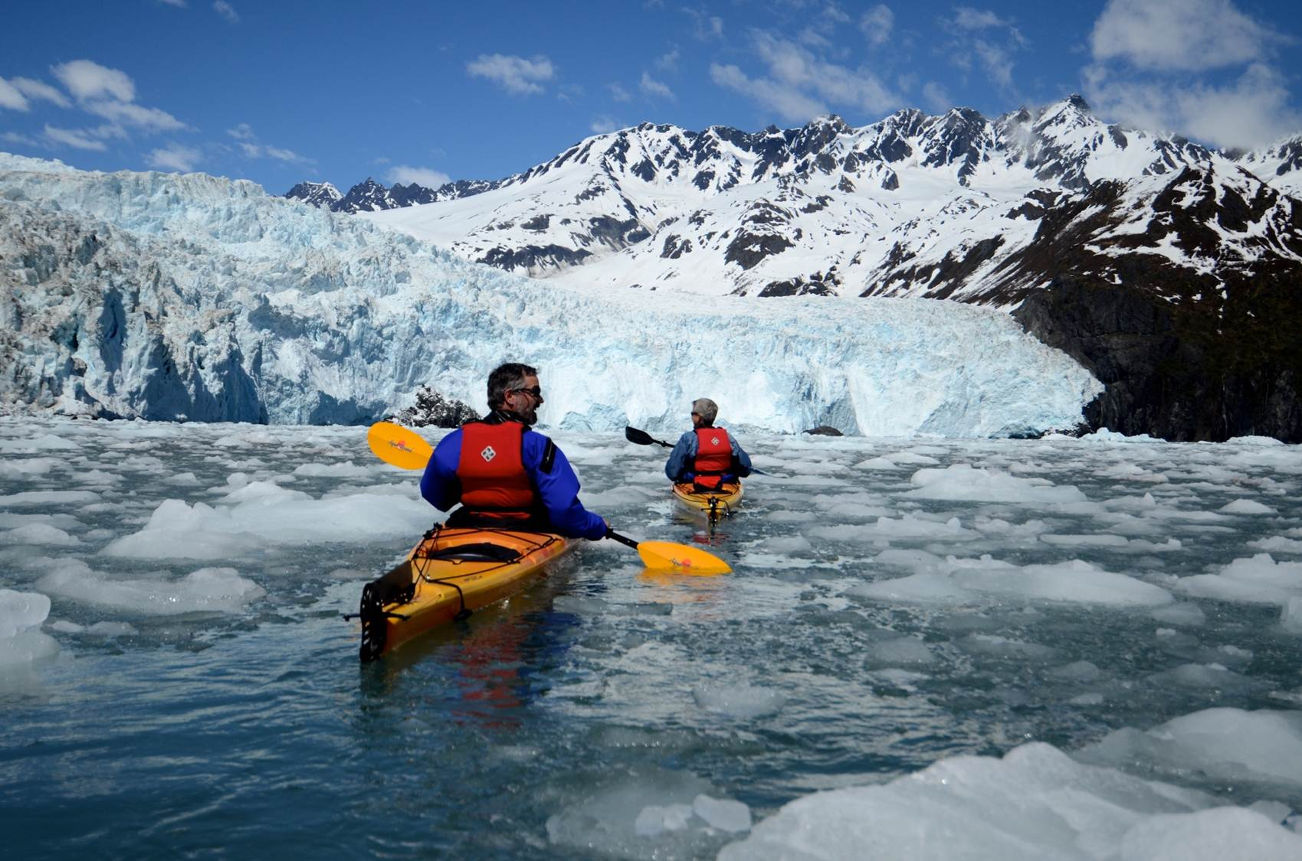

Aialik Bay Kayakers. NPS Photo

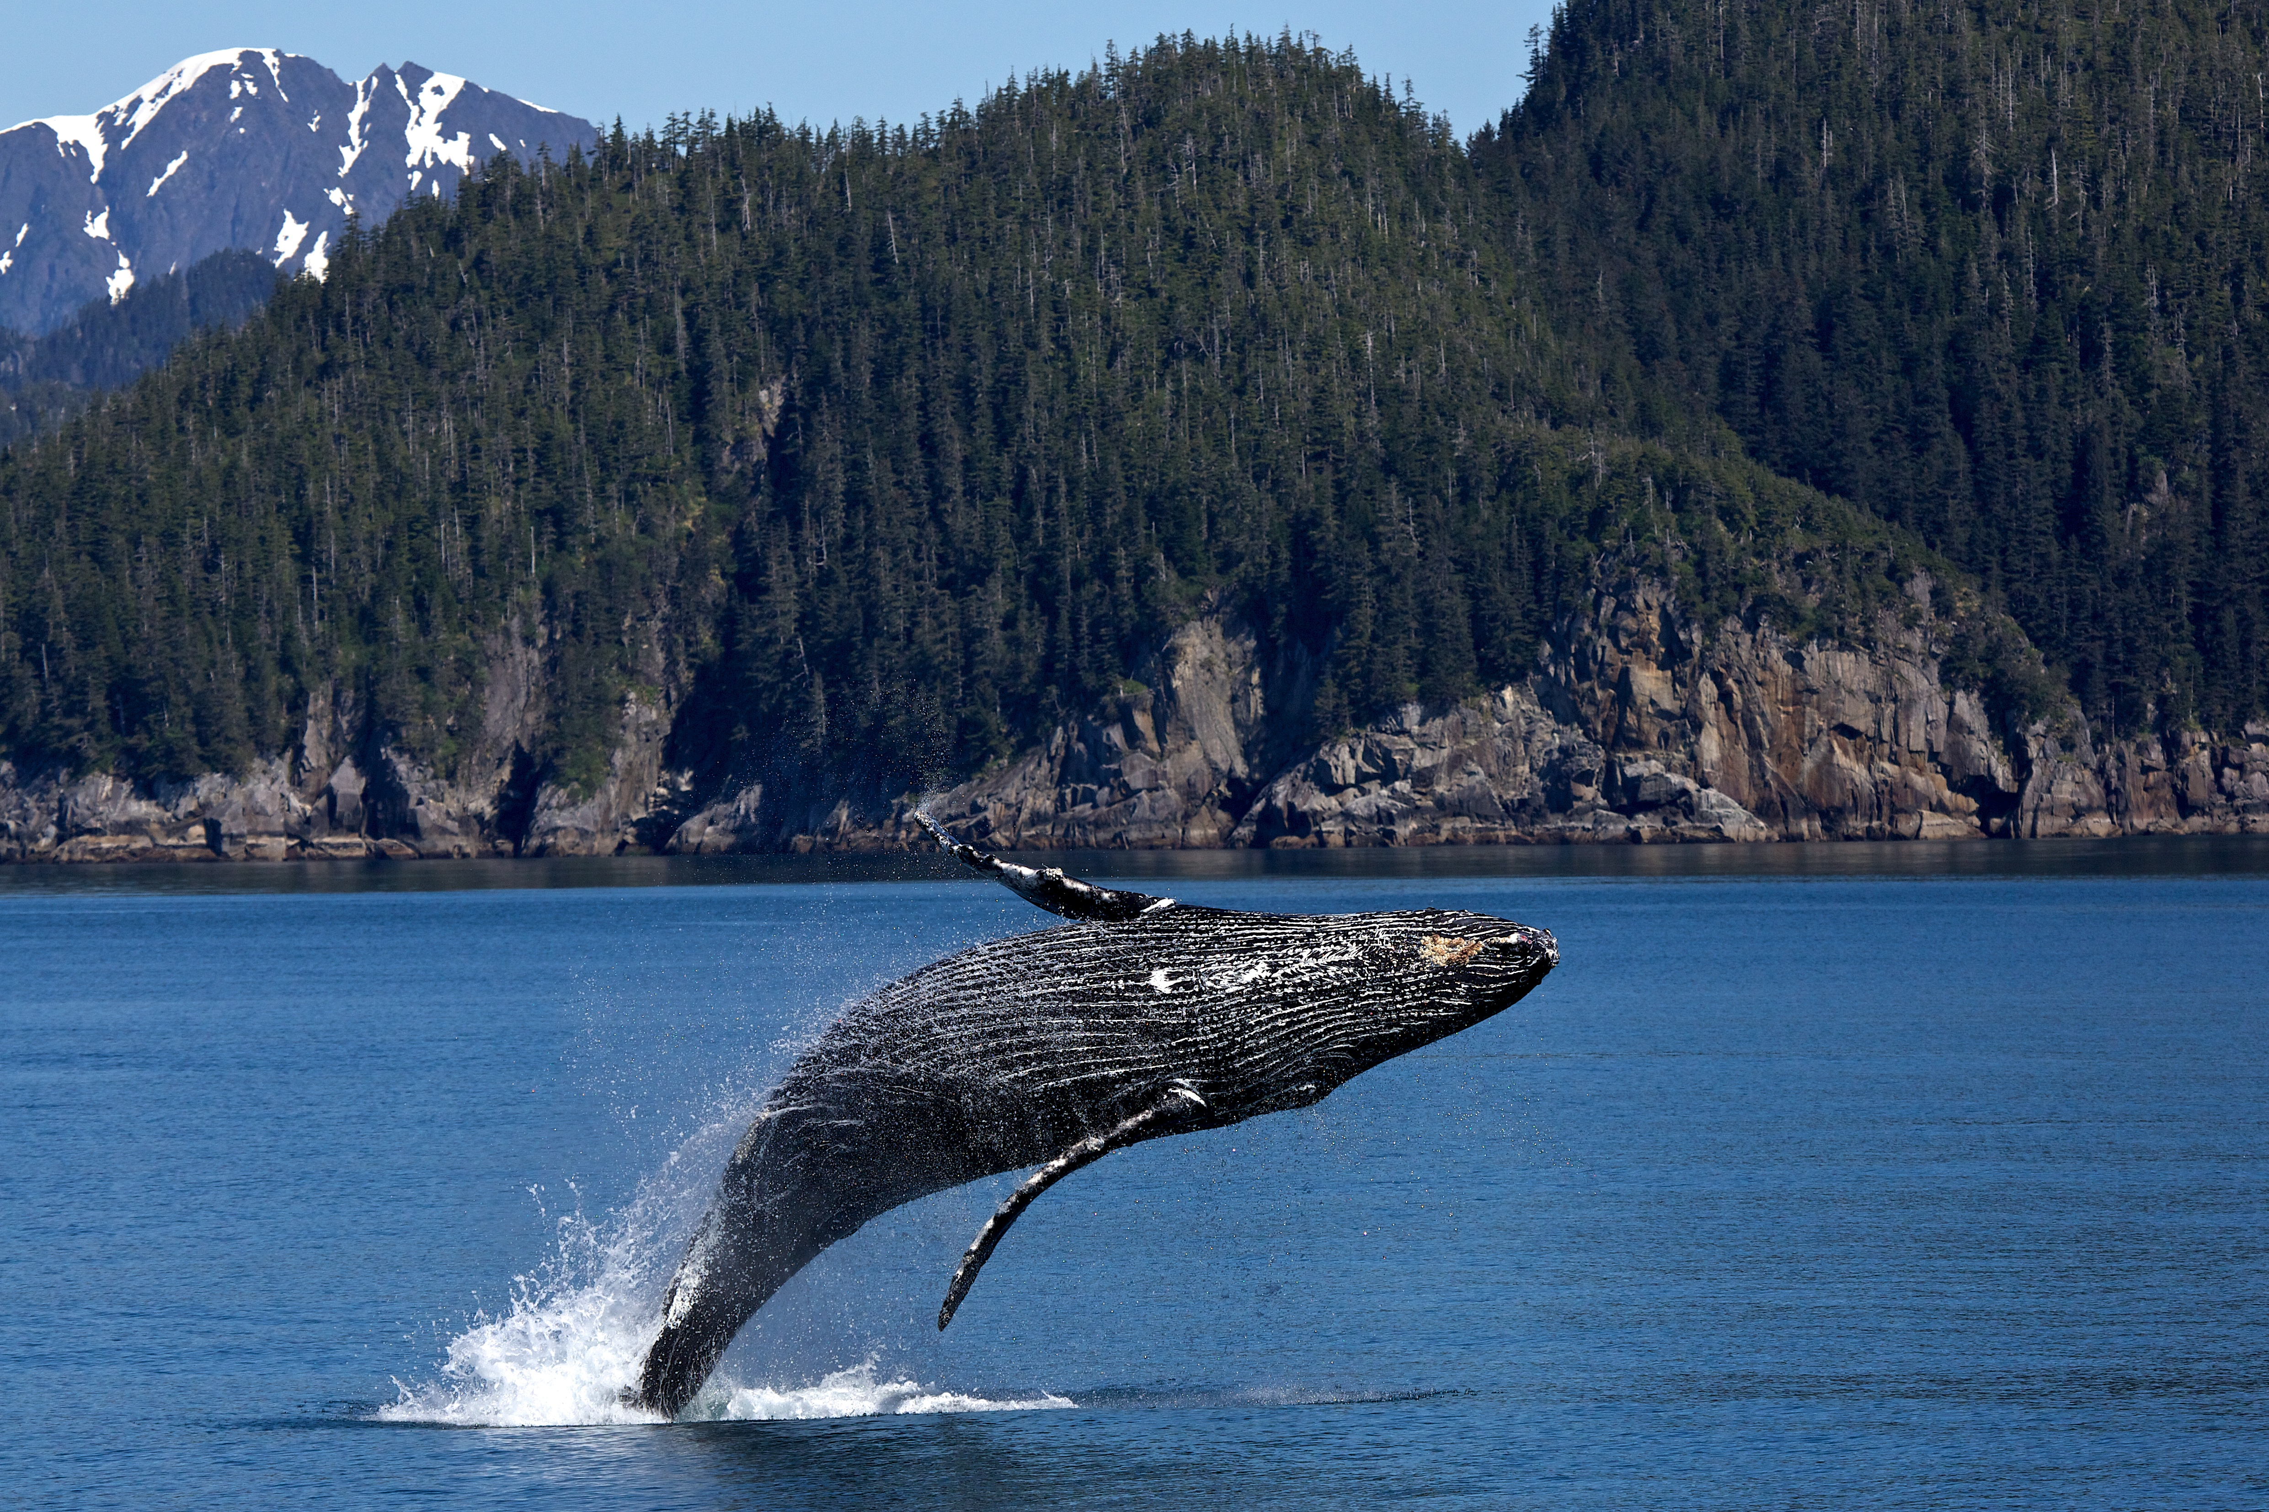

Humpback Whale Breach. NPS Photo/Thoresen

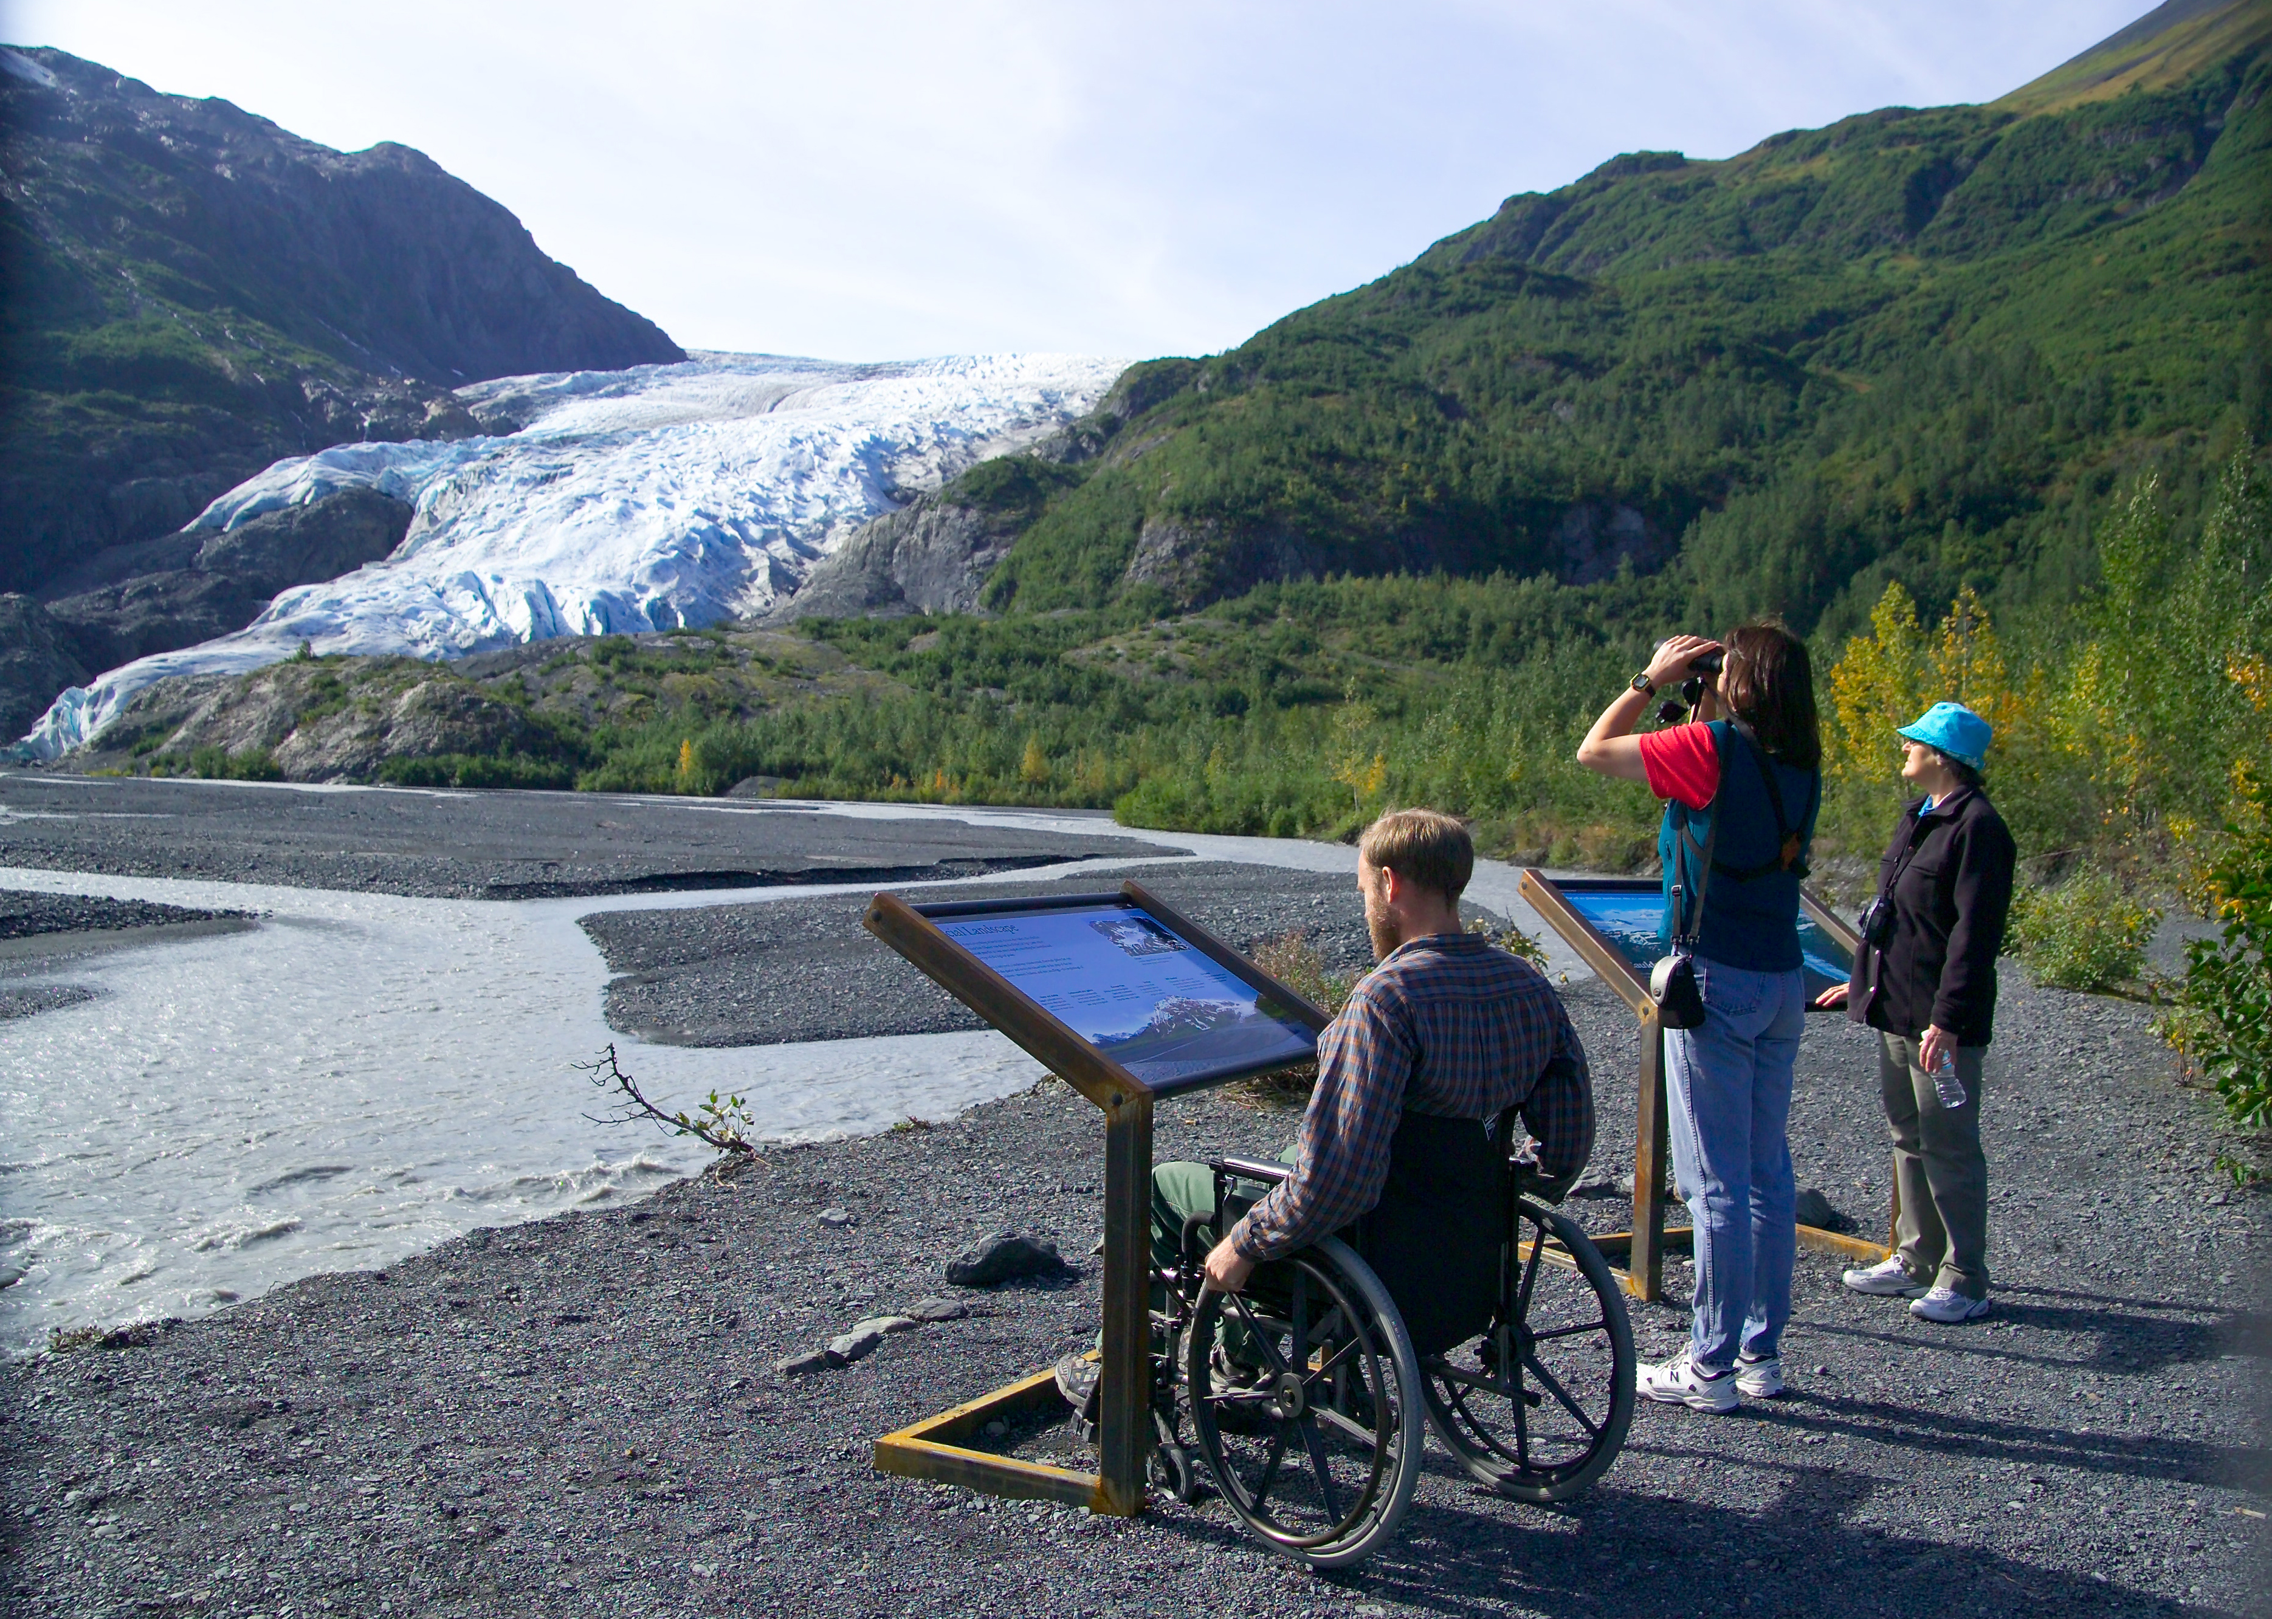

Exit Glacier View. NPS Photo/Jim Pfeiffenberger

## Operating Hours

The park is open year-round. The primary months to visit are June, July, and August. There are reduced services in the area during the months of May and September.  
  
The road to the Exit Glacier area is not plowed during the winter months, and is closed to vehicle traffic once it is covered in snow and ice.  
  
The park's coastal backcountry in also largely inaccessible late fall through the early spring due to rough seas.

## Contact Information

### Address

411 Washington Street  
AK  
99664

### Website

https://www.nps.gov/kefj/index.htm

# Crater Lake National Park

## Description

Crater Lake inspires awe. Native Americans witnessed its formation 7,700 years ago, when a violent eruption triggered the collapse of a tall peak. Scientists marvel at its purity: fed by rain and snow, it’s the deepest lake in the USA and one of the most pristine on earth. Artists, photographers, and sightseers gaze in wonder at its blue water and stunning setting atop the Cascade Mountain Range.

## Weather

Summers at Crater Lake are short but sunny. July, August, and September are your best bets for warm, dry weather. In May, June, and October, sunny days alternate with periods of rain and snow. Winters at Crater Lake are long and snowy. Storms from the Pacific Ocean dump an annual average of 43 feet (13 meters) of snow at Park Headquarters. The park's tremendous snowfall is a result of its position at the crest of the Cascade Mountains.

## Activities

* Auto and ATV
* Boat Tour
* Bus/Shuttle Guided Tour
* Dining
* Junior Ranger Program
* Shopping
* Skiing
* Snow Play
* Snowshoeing

## Images

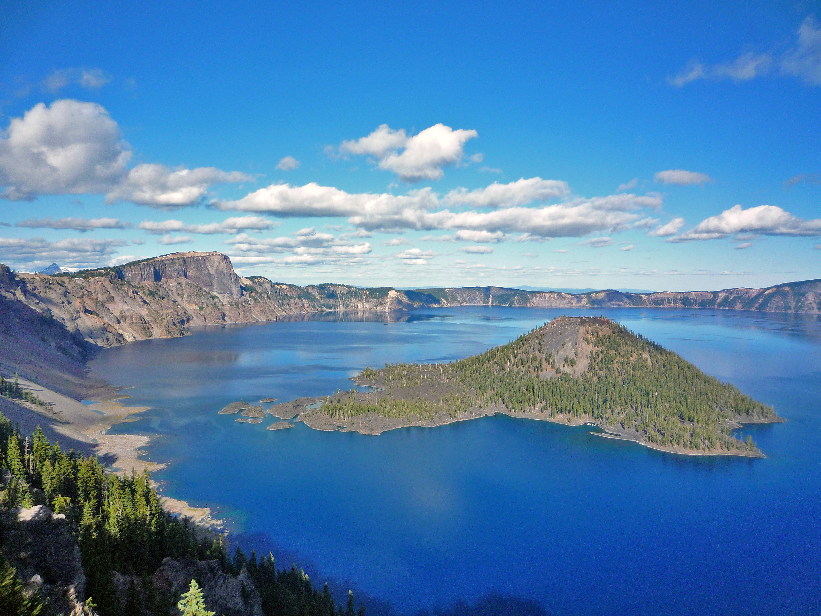

Wizard Island. NPS Photo

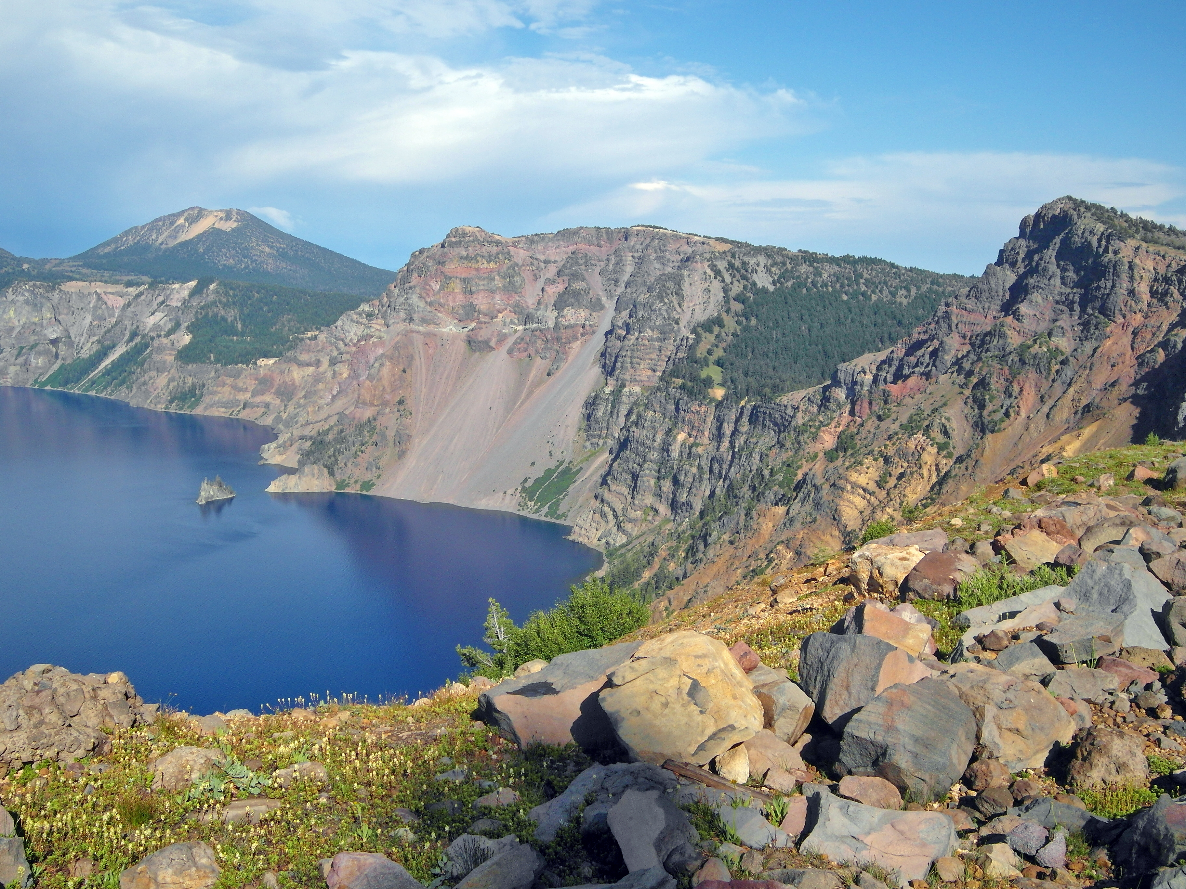

Chaski Bay. NPS Photo

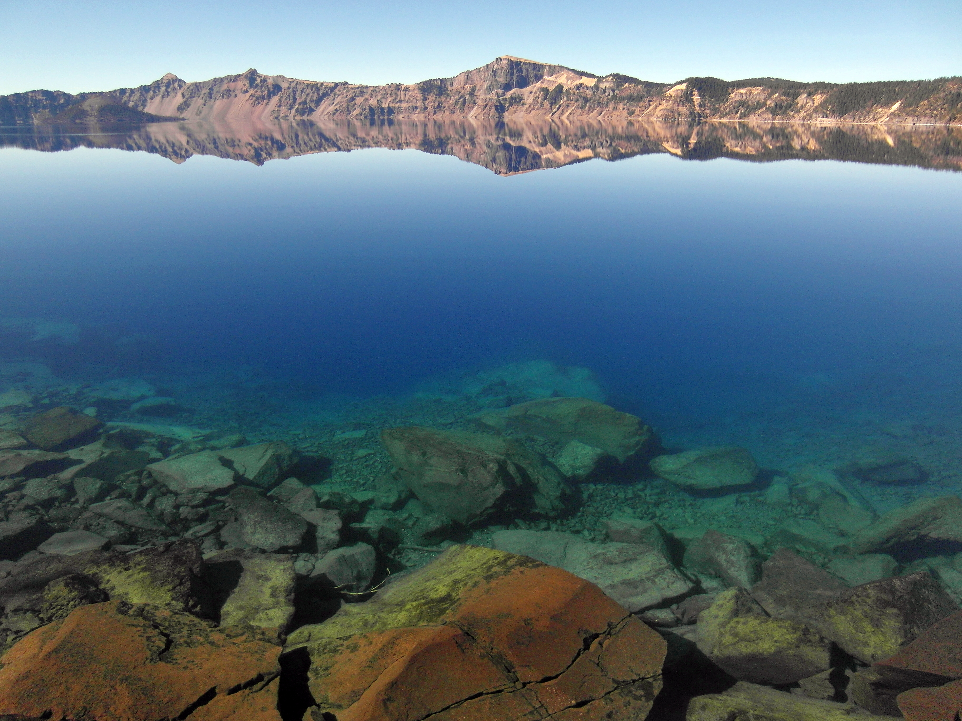

Crater Lake. NPS Photot

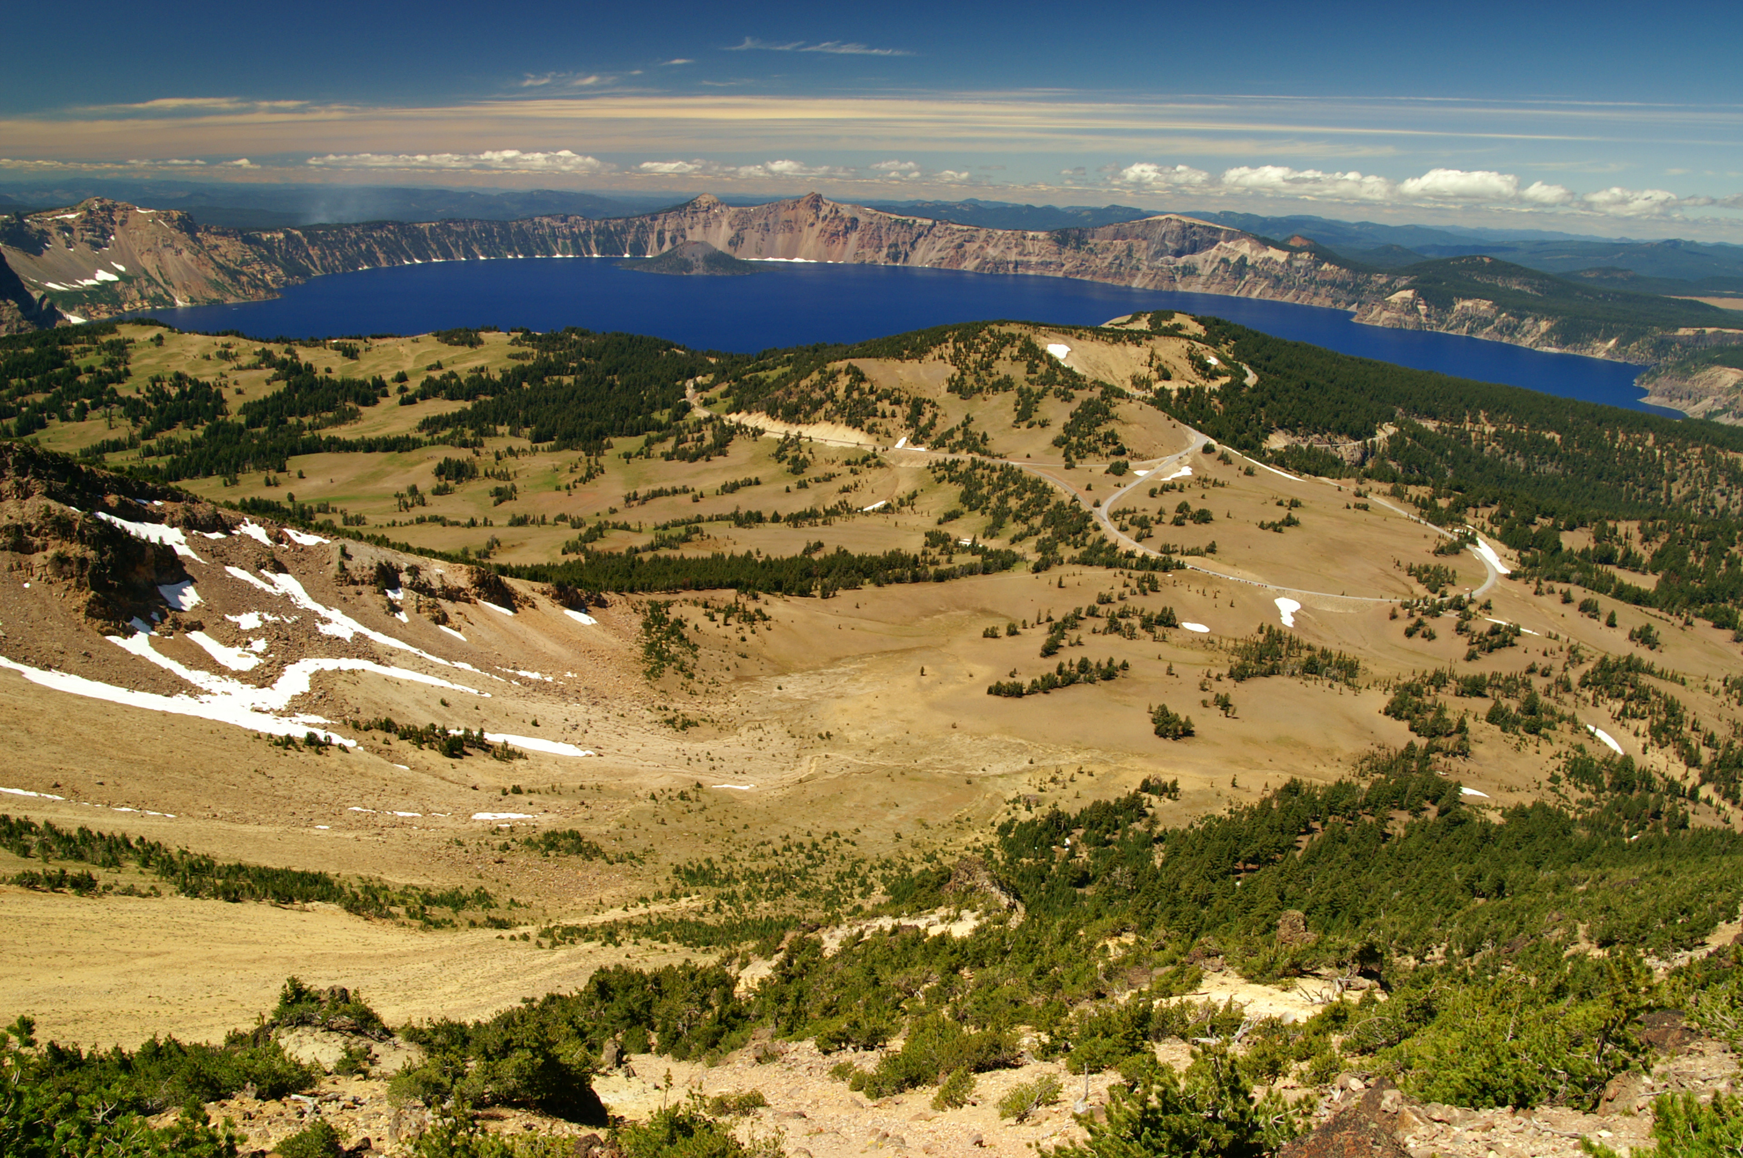

Crater Lake from Mount Scott. NPS Photo

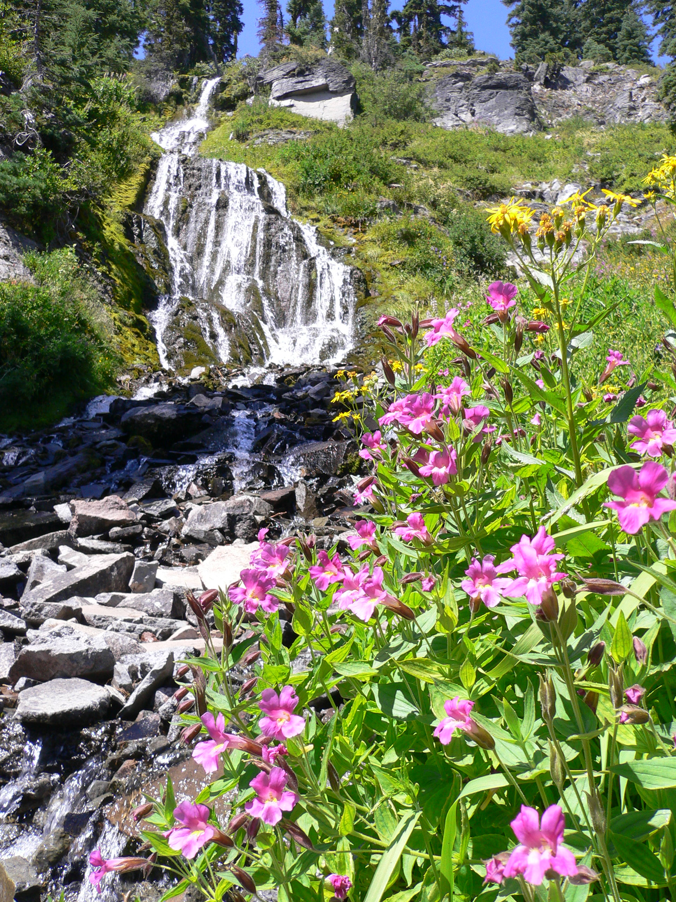

Vidae Falls. NPS Photo

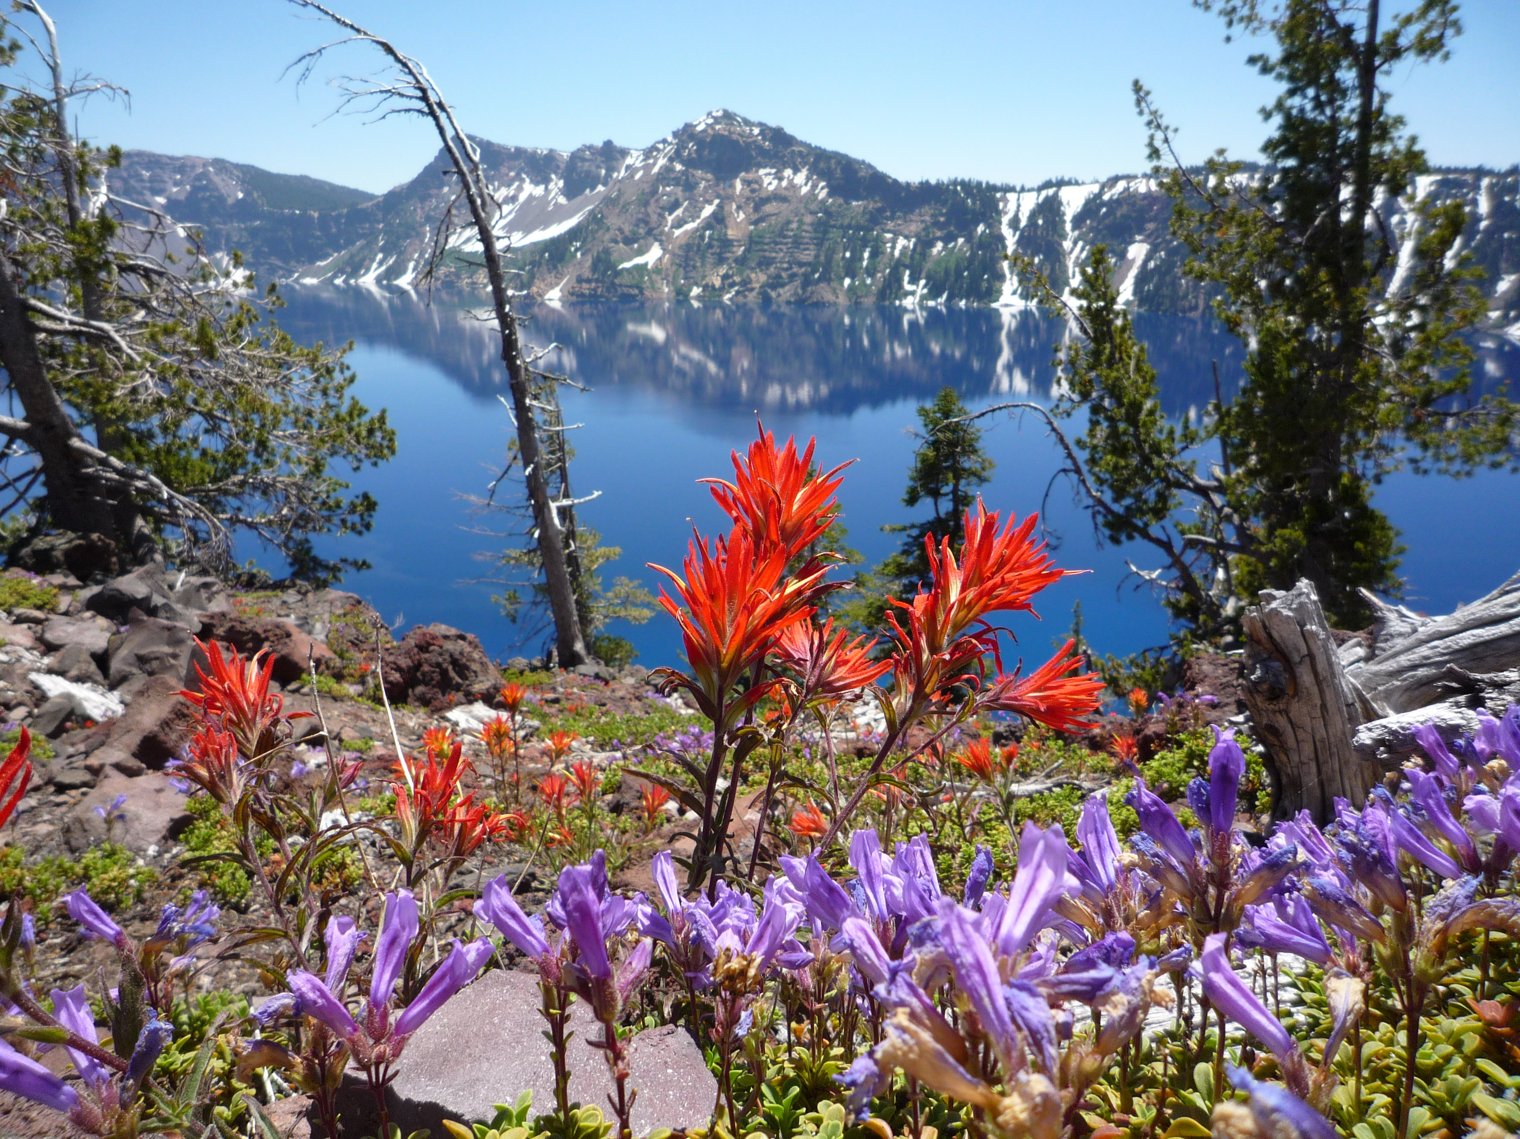

Wildflowers on Wizard Island. NPS Photo

## Operating Hours

Crater Lake National Park is open year-round, 24 hours a day. Some roads, trails, and facilities, however, are closed seasonally due to snow. North Entrance Road, and West and East Rim Drives close for the season on November 1 (or earlier if there is significant snowfall). Crews begin removing snow from these roads in April, but opening dates vary. The North Entrance Road and West Rim Drive tend to open in early June. The East Rim Drive typically opens in early July.

## Contact Information

### Address

Crater Lake National Park  
1 Sager Building  
OR  
97604

### Website

https://www.nps.gov/crla/index.htm

# Badlands National Park

## Description

The rugged beauty of the Badlands draws visitors from around the world. These striking geologic deposits contain one of the world’s richest fossil beds. Ancient horses and rhinos once roamed here. The park’s 244,000 acres protect an expanse of mixed-grass prairie where bison, bighorn sheep, prairie dogs, and black-footed ferrets live today.

## Weather

The Badlands weather is variable and unpredictable with temperature extremes ranging from 116° F to -40° F. Summers are hot and dry with occasional violent thunderstorms. Hailstorms and occasional tornadoes can descend on the Badlands with sudden fury. Winters are typically cold with 12 to 24 inches of total snowfall.

## Activities

* Astronomy
* Auto and ATV
* Car or Front Country Camping
* Food
* Gift Shop and Souvenirs
* Junior Ranger Program
* Park Film
* Wildlife Watching

## Images

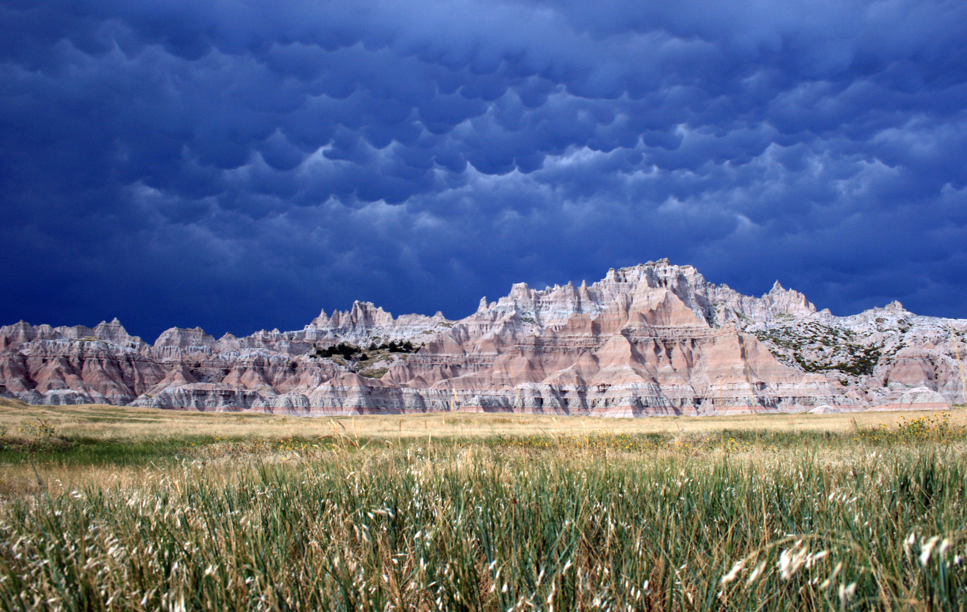

Badlands Storm. NPS Photo

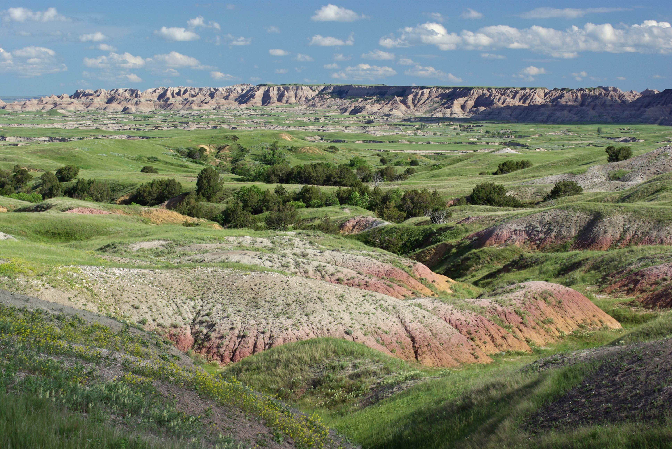

Badlands Yellow Mounds. NPS Photo

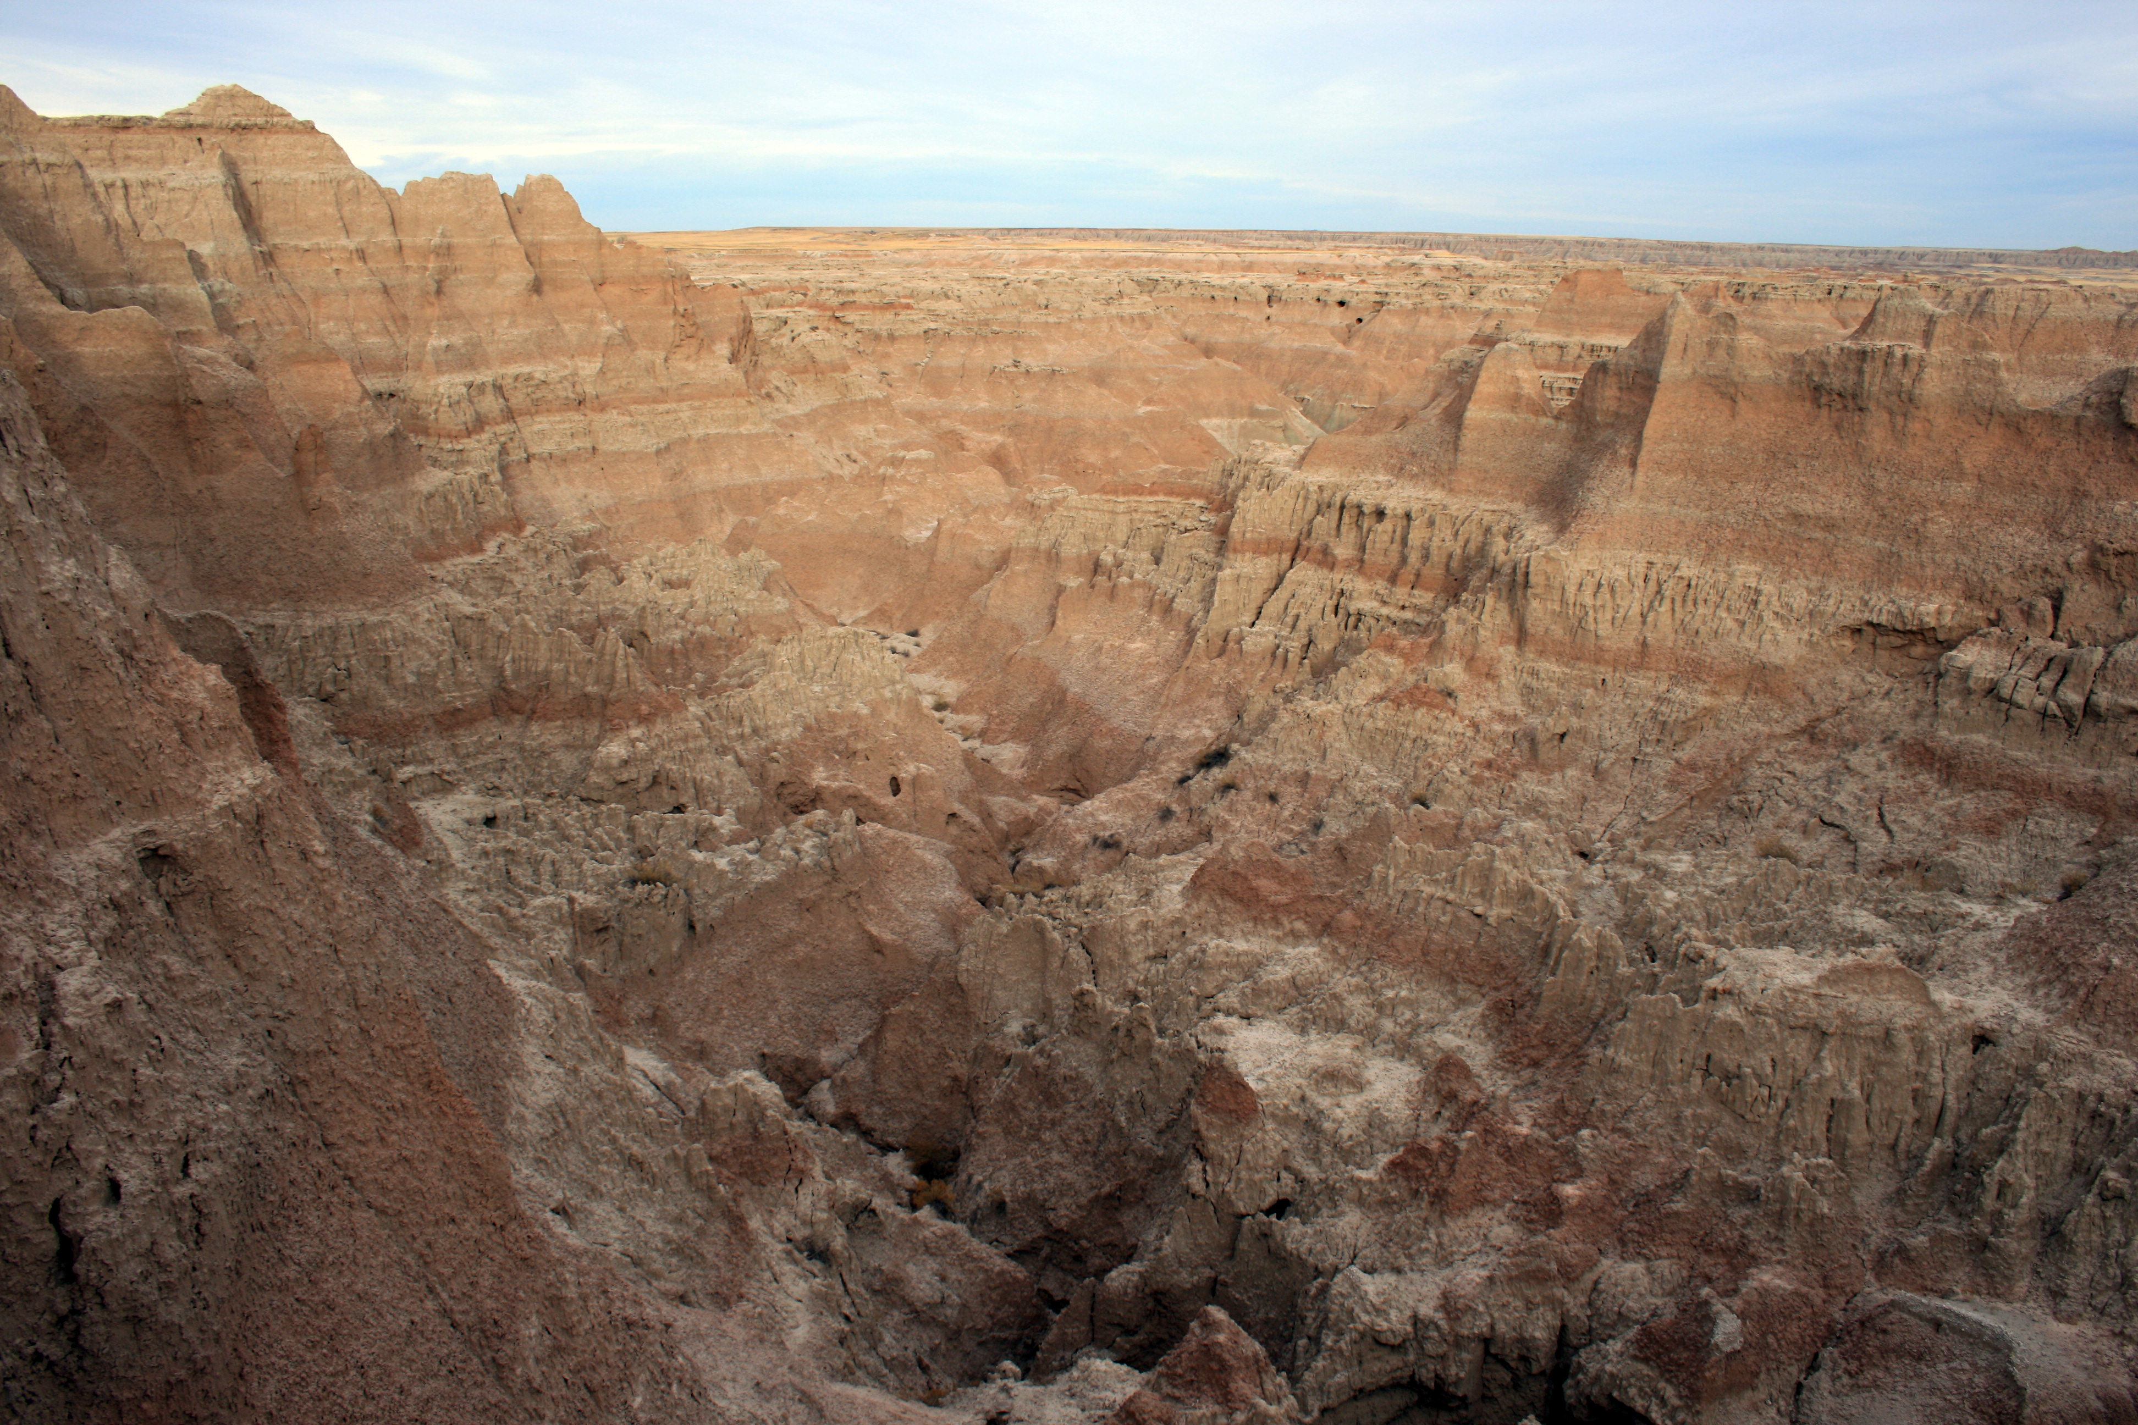

Badlands Rugged Peaks. NPS Photo

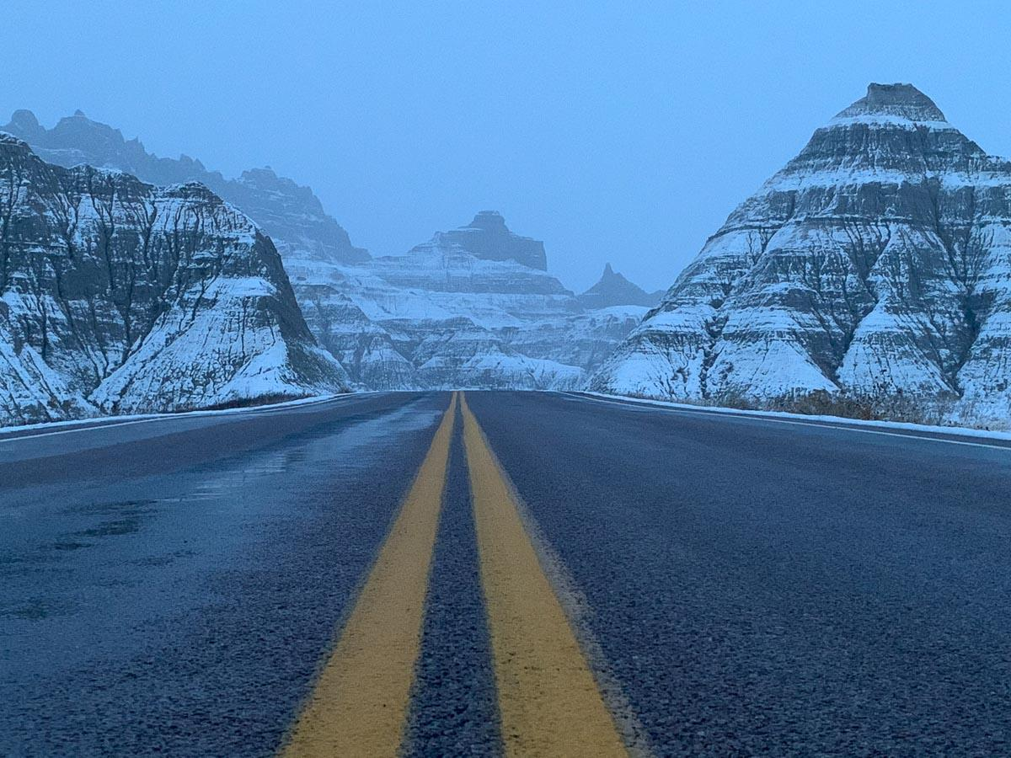

Badlands in the Winter. NPS Photo/Brad Barker

## Operating Hours

The park is open to visitors all year with the exception of weather closures.

## Contact Information

### Address

25216 Ben Reifel Road  
SD  
57750

### Website

https://www.nps.gov/badl/index.htm

# Big Bend National Park

## Description

There is a place in Far West Texas where night skies are dark as coal and rivers carve temple-like canyons in ancient limestone. Here, at the end of the road, hundreds of bird species take refuge in a solitary mountain range surrounded by weather-beaten desert. Tenacious cactus bloom in sublime southwestern sun, and diversity of species is the best in the country. This magical place is Big Bend...

## Weather

Big Bend is a desert park, so be prepared for extreme conditions. SPRING: From February through April the park abounds with pleasant and comfortable temperatures. SUMMER: May through September is very hot. Temperatures will exceed 100 degrees in the lower elevations by late morning, and often exceed 110 along the Rio Grande. Afternoon thunderstorms can be a welcome respite. WINTER: October through January temperatures are cooler; the weather can quickly turn cold at any time during these months.

## Activities

* Auto and ATV
* Canoe or Kayak Camping
* Canoeing
* Fishing
* Junior Ranger Program
* Kayaking
* Paddling
* Wildlife Watching

## Images

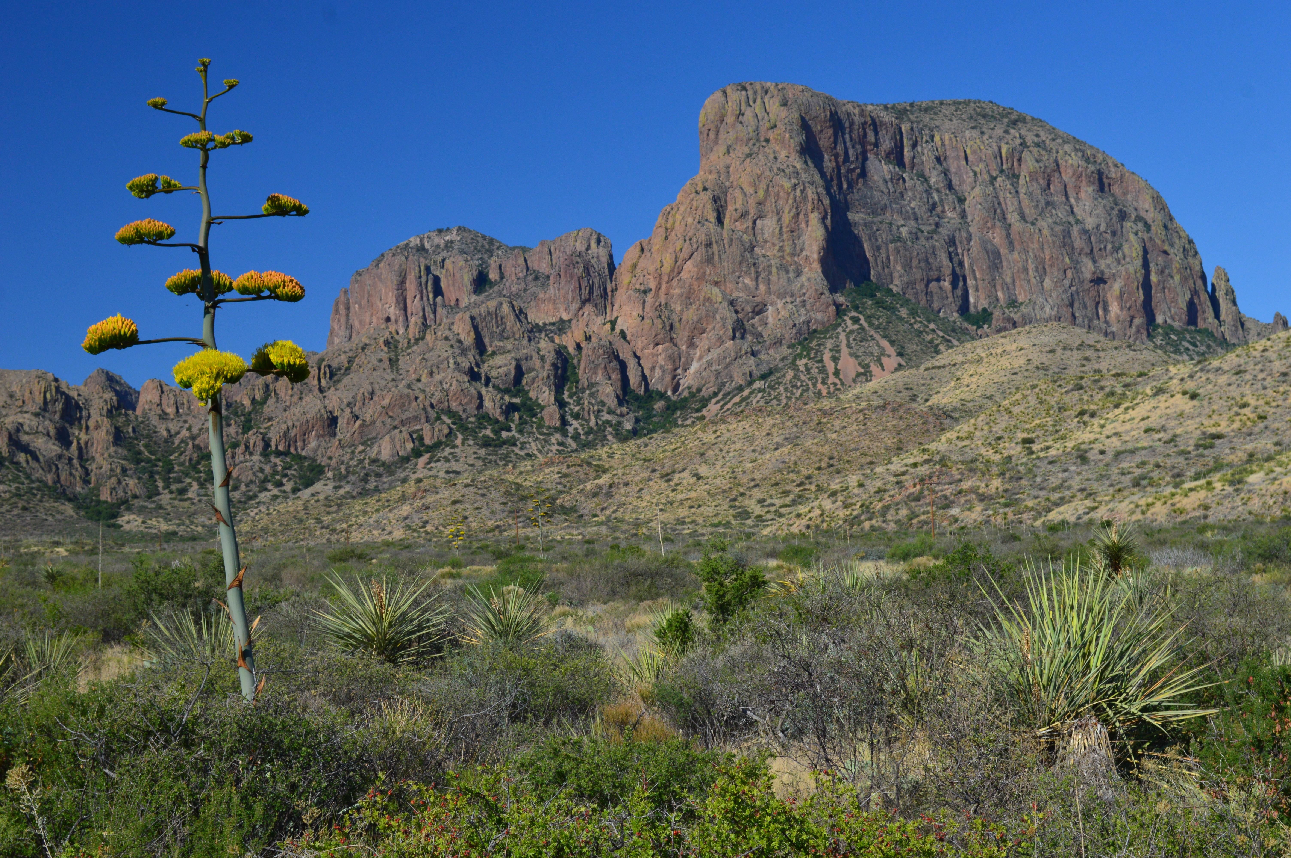

Century Plant Agave. NPS / C. Negele

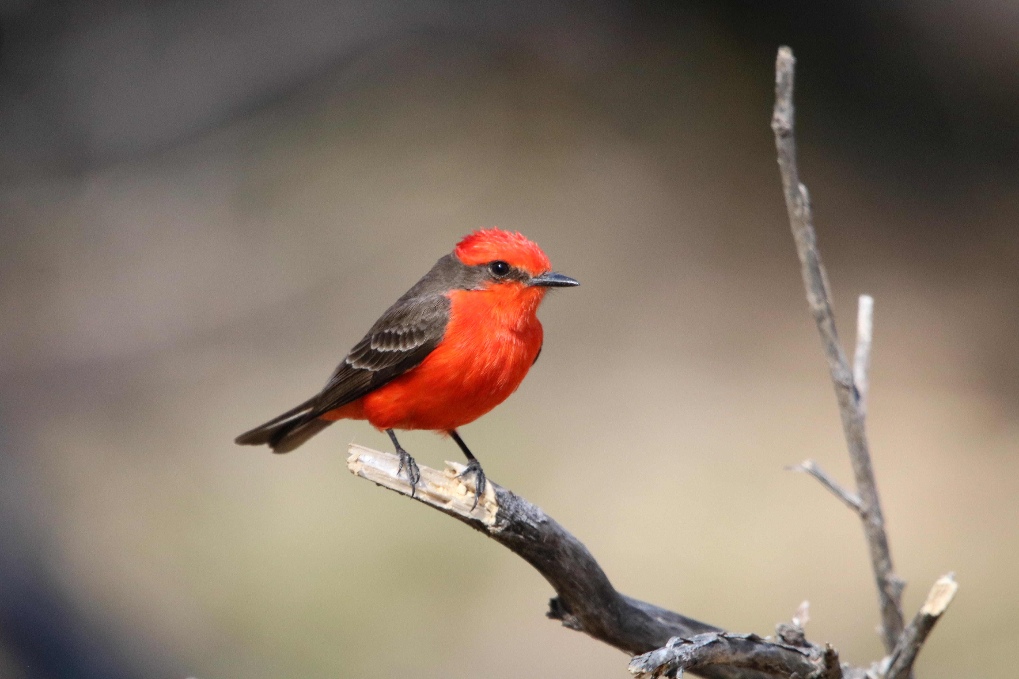

Vermilion Flycatcher. NPS

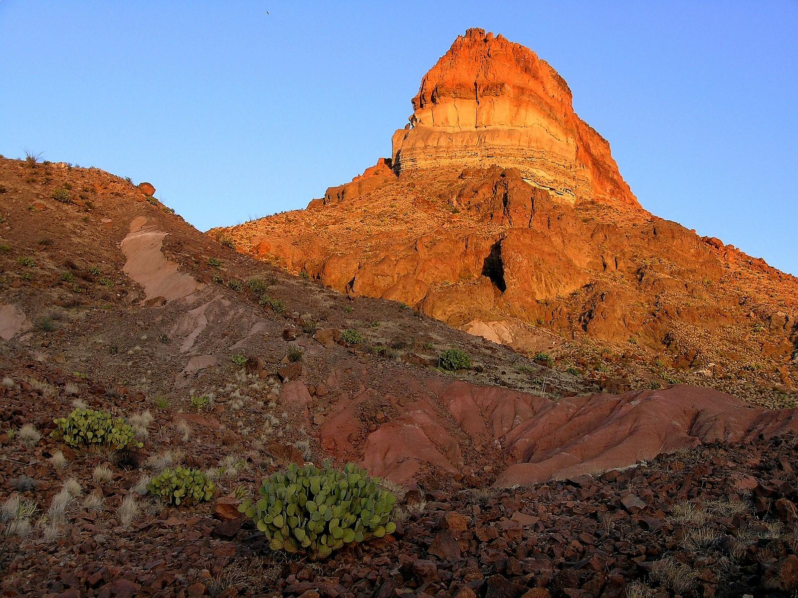

Fascinating Geology. NPS / B. Trester

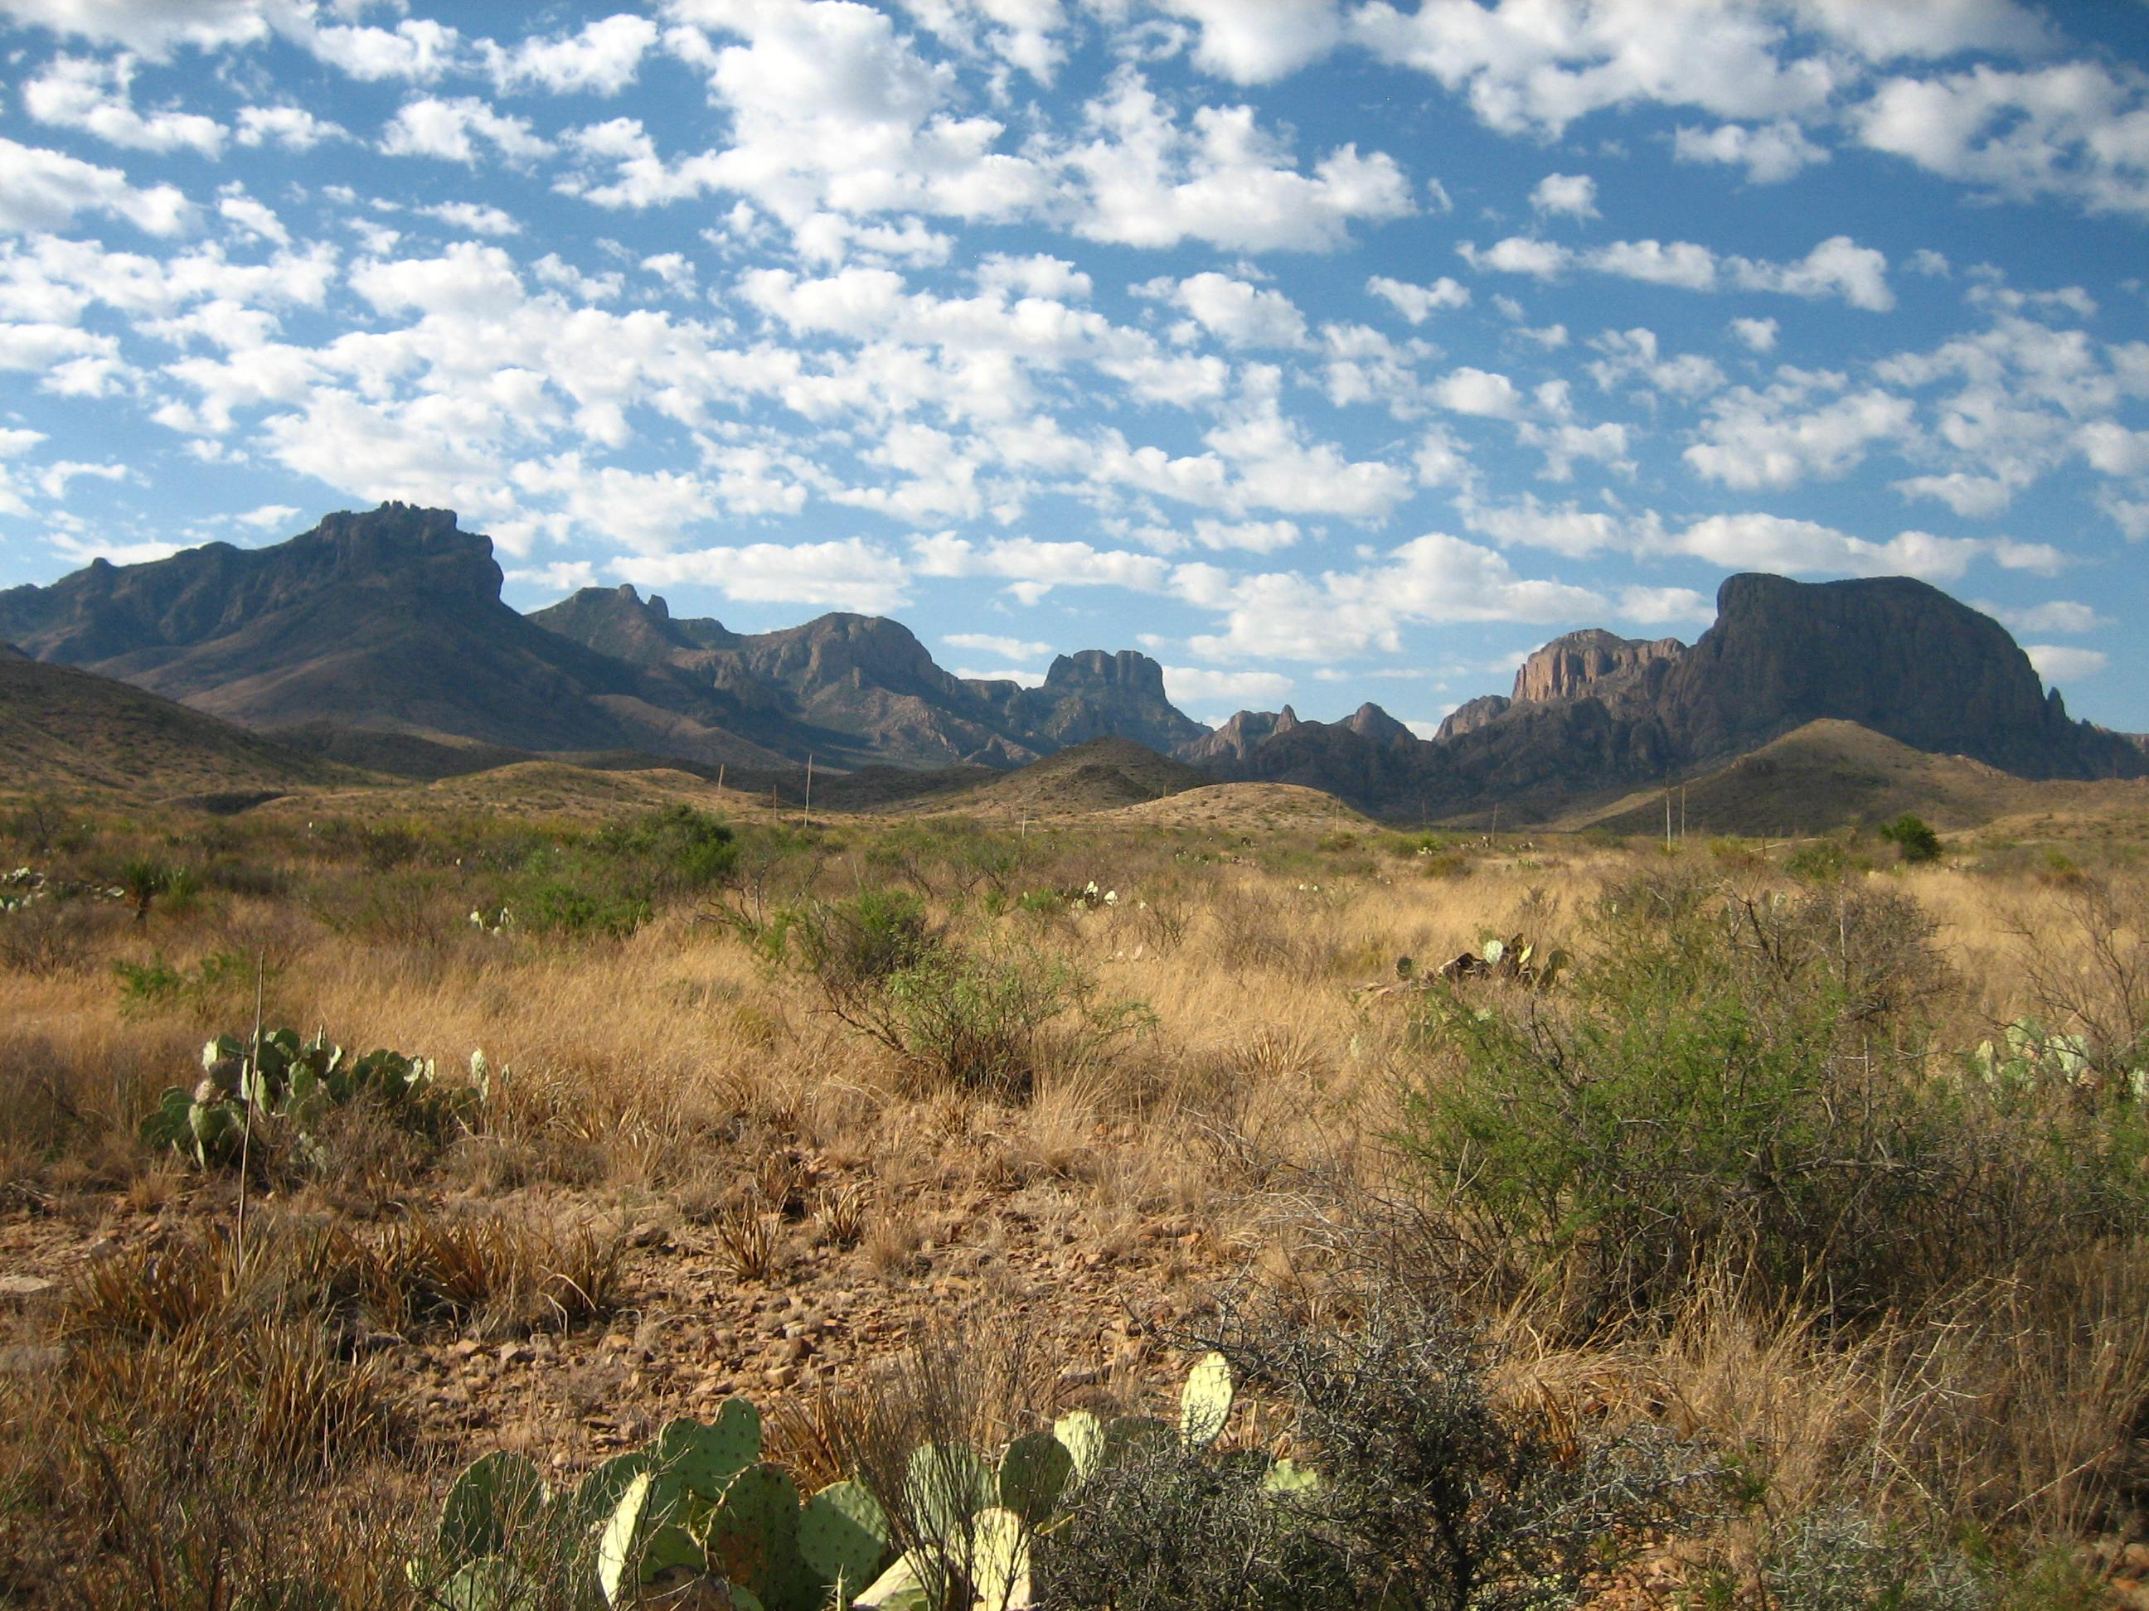

Desert Scenery. NPS

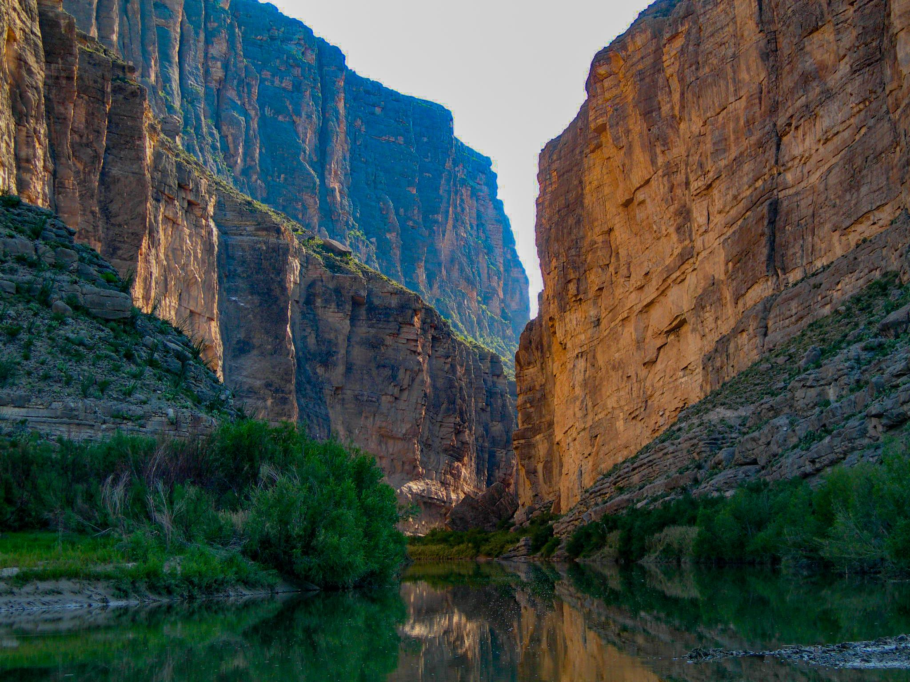

Santa Elena Canyon. NPS / B. Trester

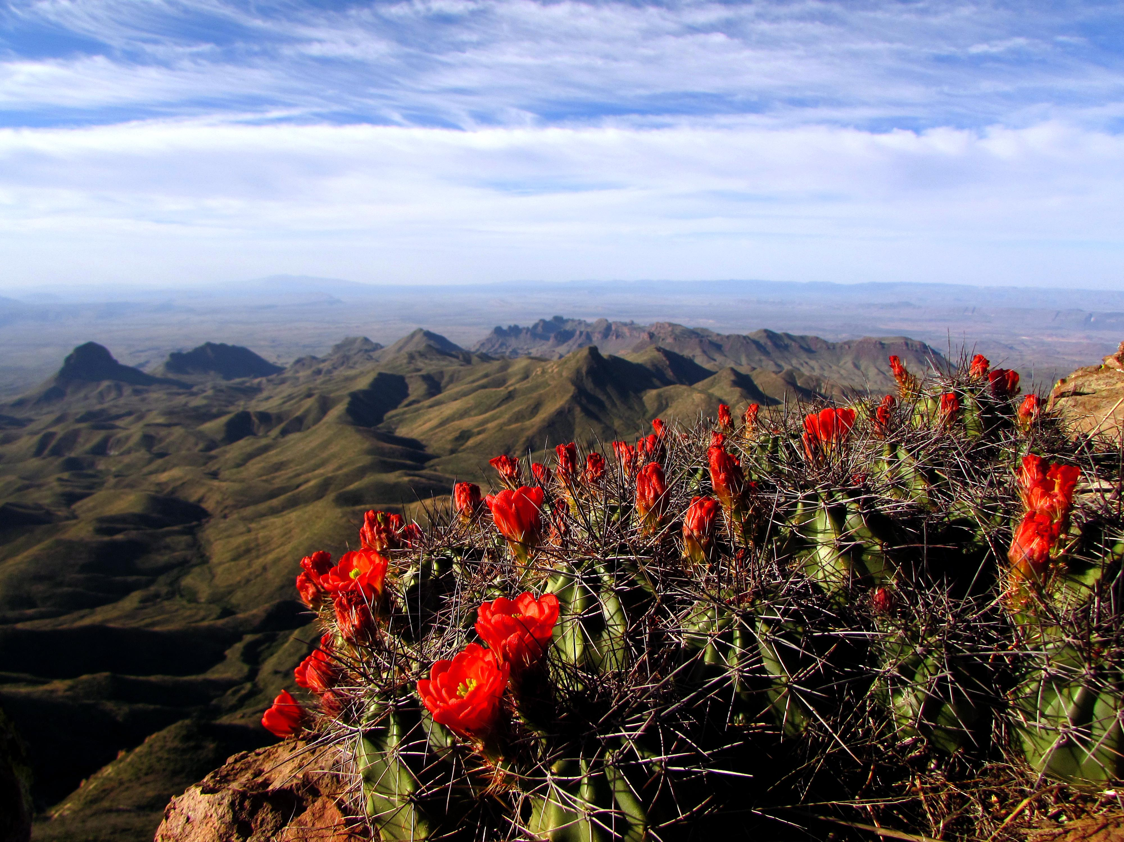

View from the South Rim of the Chisos. NPS

## Operating Hours

Big Bend National Park is always open. You can enter and exit at any time of the day or night. Park entrances are open 24 hours daily, all year.

## Contact Information

### Address

1 Panther Junction  
TX  
79834

### Website

https://www.nps.gov/bibe/index.htm